5MP HD Intelligent Lighthunter IR VF Eyeball Network Camera
IPC3635SB-ADZK-I0

Key Features
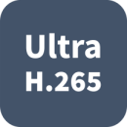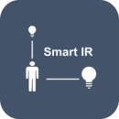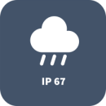

Smart
- Smart Intrusion Prevention, include Cross Line, Intrusion, Enter Area, Leave Area detection
- Based on target classification, smart intrusion prevention significantly reduce false alarm caused by leaves, birds and lights etc., accurately focus on human and vehicle.

Optics
- Day/night functionality
- Smart IR, up to 40m (131ft) IR distance
- Up to 120 dB WDR (Wide Dynamic Range)
- 2D/3D DNR (Digital Noise Reduction)

Compression
- Ultra 265, H.265,H.264, MJPEG
- ROI (Region of Interest)
- Customized OSD

Network
- ONVIF conformance

Structure
- Wide temperature range: -30°C ~ 60°C (-22°F ~ 140°F)
- Wide voltage range of ±25%
- IP67
- IK10 vandal resistant
- 3-Axis

Specifications
 | IPC3635SB-ADZK-I0
Camera
Sensor | 1/2.7", 5.0 megapixel, progressive scan, CMOS
Lens | 2.7 ~ 13.5mm, AF automatic focusing and motorized zoom lens
DORI Distance | Lens (mm) | Detect (m) |  | Observe (m) | Recognize (m) |  | Identify (m)
 | 2.7 | 60.8 |  | 24.3 | 12.2 |  | 6.1
 | 13.5 | 303.8 |  | 121.5 | 60.8 |  | 30.4
Angle of view (H) | 106.25°~ 30.42°
Angle of View (V) | 56.36°~ 17.22°
Angle of View (O) | 110.34°~34.18°
Adjustment angle | Pan: 0° ~ 360° |  | Tilt: 0° ~ 75° |  |  | Rotate: 0° ~ 360°
Shutter | Auto/Manual, 1 ~ 1/100000s
Minimum Illumination | Colour: 0.002Lux (F1.35, AGC ON)  0Lux with IR
Day/Night | IR-cut filter with auto switch (ICR)
Digital noise reduction | 2D/3D DNR
S/N | >56dB
IR Range | Up to 40m (131ft) IR range
Wavelength | 850nm
IR On/Off Control | Auto/Manual
Defog | Digital Defog
WDR | 120dB
Video
Video Compression | Ultra 265,H.265, H.264, MJPEG
H.264 code profile | Baseline profile, Main Profile, High Profile
Frame Rate | Main Stream:5MP (2880*1620), Max 25fps; 4MP (2560*1440), Max 25fps; 3MP (2304*1296), Max 25fps; 1080P (1920*1080), Max 30fps;  Sub Stream: D1 (720*576), Max 30fps;  Third Stream: CIF (352*288), Max 30fps
Video Bit Rate | 128 Kbps~16 Mbps
9:16 Corridor Mode | Supported
OSD | Up to 8 OSDs
Privacy Mask | Up to 4 areas
ROI | Up to 8 areas
Motion Detection | Up to 4 areas
Image
White Balance | Auto/Outdoor/Fine Tune/Sodium Lamp/Locked/Auto2
Digital noise reduction | 2D/3D DNR
Smart IR | Support
Flip | Normal/Vertical/Horizontal/180°/90°Clockwise/90°Anti-clockwise
Dewarping | Supported
HLC | Supported
BLC | Supported
Audio
Audio Compression | G.711
Suppression | Supported
Sampling Rate | 8KHZ
Storage
Edge Storage | Micro SD, up to 256GB
Network Storage | ANR, NAS(NFS)
Smart
Smart intrusion Prevention | Cross Line, Intrusion, Enter Area, Leave Area detection;
Basic Detection | Motion detection, Tampering alarm, Audio Detection
General Function | Watermark, IP Address Filtering, Tampering Alarm, Access Policy, ARP Protection, RTSP Authentication, User Authentication
Network
Protocols | IPv4, IGMP, ICMP, ARP, TCP, UDP, DHCP, RTP, RTSP, RTCP, DNS, DDNS, NTP, FTP, UPnP, HTTP, HTTPS, SMTP, SSL, SNMP
Compatible Integration | ONVIF (Profile S, Profile G, Profile T), API
Client | EZStation  EZView  EZLive
Web Browser | Plug-in required live view: IE9+, Chrome 41 and below, Firefox 52 and below
 | Plug-in free live view: Chorme 57.0+, Firefox 58.0+, Edge 16+, Safari 11+
Interface
Built-in Mic | Supported
Network | 1 RJ45 10M/100M Base-TX Ethernet
Certifications
Certifications | CE: EN 60950-1  UL: UL60950-1  FCC: FCC Part 15
General
Power | DC 12V±25%, PoE (IEEE 802.3af)
 | Power consumption: Max 7.0 W
Dimensions (Ø x H) | Φ129 x 110mm (Ø5.1” x 4.3”)
Net Weight | 0.70kg (1.52lb)
Material | Metal
Working Environment | -30°C ~ 60°C (-22°F ~ 140°F), Humidity: ≤95% RH (non-condensing)
Strorage Environment | -30°C ~ 60°C (-22°F ~ 140°F), Humidity: ≤95% RH (non-condensing)
Surge Protection | 6KV
Ingress Protection | IP67
vandal resistant | IK10
Reset Button | Supported

Dimensions
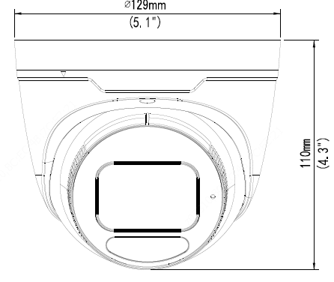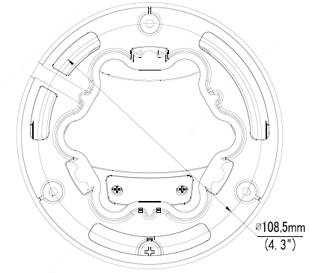

Accessories
TR-JB03-H-IN TR-JB07/WM03-F-IN TR-WM03-B-IN TR-UP06-IN TR-A01-IN
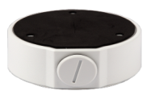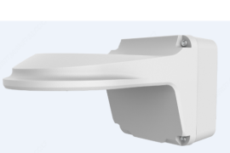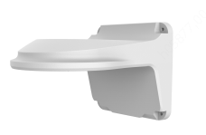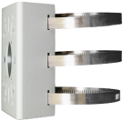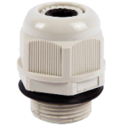
TR-SE24-IN TR-SE24-A-IN TR-CM24-IN

Junction Mount | Pole Mount
TR-JB03-H-IN | TR-JB07/WM03-F-IN(TR-WM03-B-IN)+TR-UP06-IN
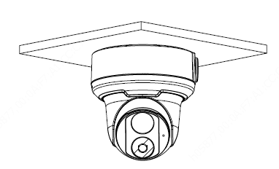 | 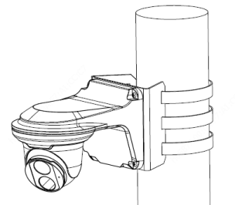
TR-CM24-IN+TR-JB03-H-IN
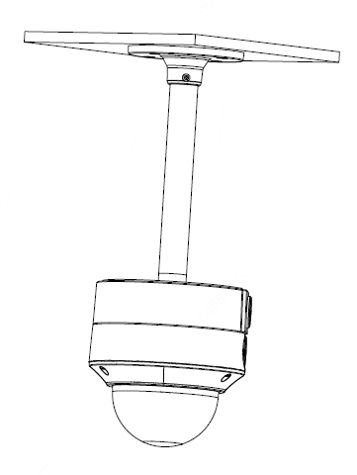

Zhejiang Uniview Technologies Co., Ltd.
Building No.10, Wanlun Science Park, Jiangling Road 88, Binjiang District, Hangzhou, Zhejiang, China (310051)
Email: overseasbusiness@uniview.com; globalsupport@uniview.com
http://www.uniview.com
©2020 Zhejiang Uniview Technologies Co., Ltd. All rights reserved.
*Product specifications and availability are subject to change without notice.

