OET-231KH@TWD Face Recognition Access Control Terminal

Product Overview
OET-231KH@TWD face recognition access control terminal is a kind of access control device with precise recognition rate, large storage capacity and fast recognition. The UNV face recognition technology is perfectly integrated into the access control device, which relies on deep learning algorithm, to support face authentication to open the door and achieve precise control of human. And it can be widely applied to the scenarios of building systems, such as smart communities, public security, parks and other important areas.
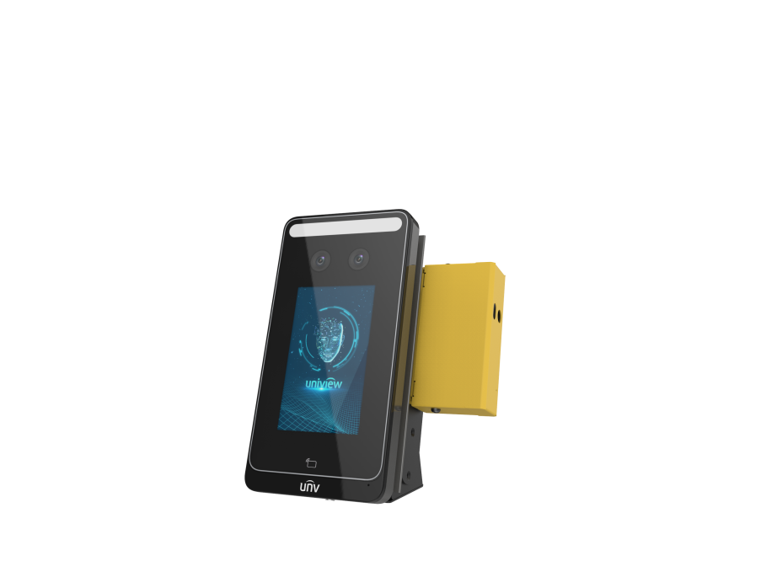

Product Features
- Deep learning algorithm model based on UNV independent intellectual property rights, face recognition accuracy rate $>$ 99$\%$, false rate $<$ 1$\%$
- Built-in deep learning dedicated chip, supports local offline recognition, 3,000 face capacity, face whitelist (1$∶$N), 10,000 IC card capacity
- Fastest recognition time 0.2 seconds, various model merge mode are used to reduce false rate and increase pass rate
- WDR, 2MP (1080P) low illumination wide-angle camera for capturing high quality image with various complex lighting scenes
- Support anti-spoofing detection based on deep learning algorithm, effective against fraud such as photo and video
- Support face metering and human metering for fast adapting to ambient light
- Suggested height for face recognition: between 0.8m and 2.2m，face recognition distance: 0.2m to 2.9m
- Support screen sleep mode, keep the minimum brightness to prevent glare at night
- Support add up to 6 photos of the base library for a single person
- Support video capture, support ONVIF protocol
- Support face, card authentication to control door open
- Built-in 4G EMMC front end storage, stable and reliable, up to 8,000 events capacity (with images)
- Support direct control door lock, exit button, door contact detection to implement access control management
- Support tamper protection, support door open timeout and time exceed alarm function to keep door opening during fire alarm active

Ordering Information
Model | Comment
OET-231KH@TWD | Face recognition access control terminal with digital temperature measurement module

Product Specification
Features Parameter | Description
Operation System | Linux
Face Recognition Accuracy Rate | $>$99$\%$
Face Recognition Time | 200ms
Face Capacity | 3,000
Card Capacity | 6,000
Storage Capacity | 4GB
Event Capacity | 8,000 (with images)
Measurement Range | 30℃-45℃
Measurement Accuracy | 0.1℃
Measurement Deviation | $≤$0.3℃
Measurement Distance | 1cm-4cm
Authentication Mode | Face Whitelist$∶$(1$∶$N)
 | Card:(1:N)
 | Face +Body temperature+ Mask Detection
Door Opening Method | Face, Card
Communication Mode | 10/100Mbps adaptive network port
Card Type | Mifare 1 Card
User Management | Support user library addition, deletion, update
Record Management | Support local recording and real-time upload
Interface | LAN×1，RS485×1，Alarm Input×1，Alarm Output×1， Lock×1，SEN_INPUT×1，BUTTON_INPUT×1，VDD12 INPUT×1，GND×4
Power Supply | Input 12V$±$25$\%$ DC
Screen | Touch Screen, Size:4 inch, Resolution: 480×800
Camera | Dual Lens, 2MP, 1080P
Supplement Light | LED soft light and infrared light
Dimensions (L$×$W$×$H) | 88.0mm$×$33.0mm$×$175.0mm
Working Environment | For terminal: $-$10$℃$-50$℃$, Relative Humidly$<$95$\%$ (non-condensing)  For module: $10℃$-40$℃$
Application Situation | Indoor,

Zhejiang Uniview Technologies Co., Ltd.
Building No.10, Wanlun Science Park, Jiangling Road 88, Binjiang District, Hangzhou, Zhejiang, China (310051)
Email:overseasbusiness@uniview.com; globalsupport@uniview.com
http://www.uniview.com
©2019 Zhejiang Uniview Technologies Co., Ltd. All rights reserved.
*Product specifications and availability are subject to change without notice.

