4MP Fixed Eyeball Network Camera
EC-T4F28M
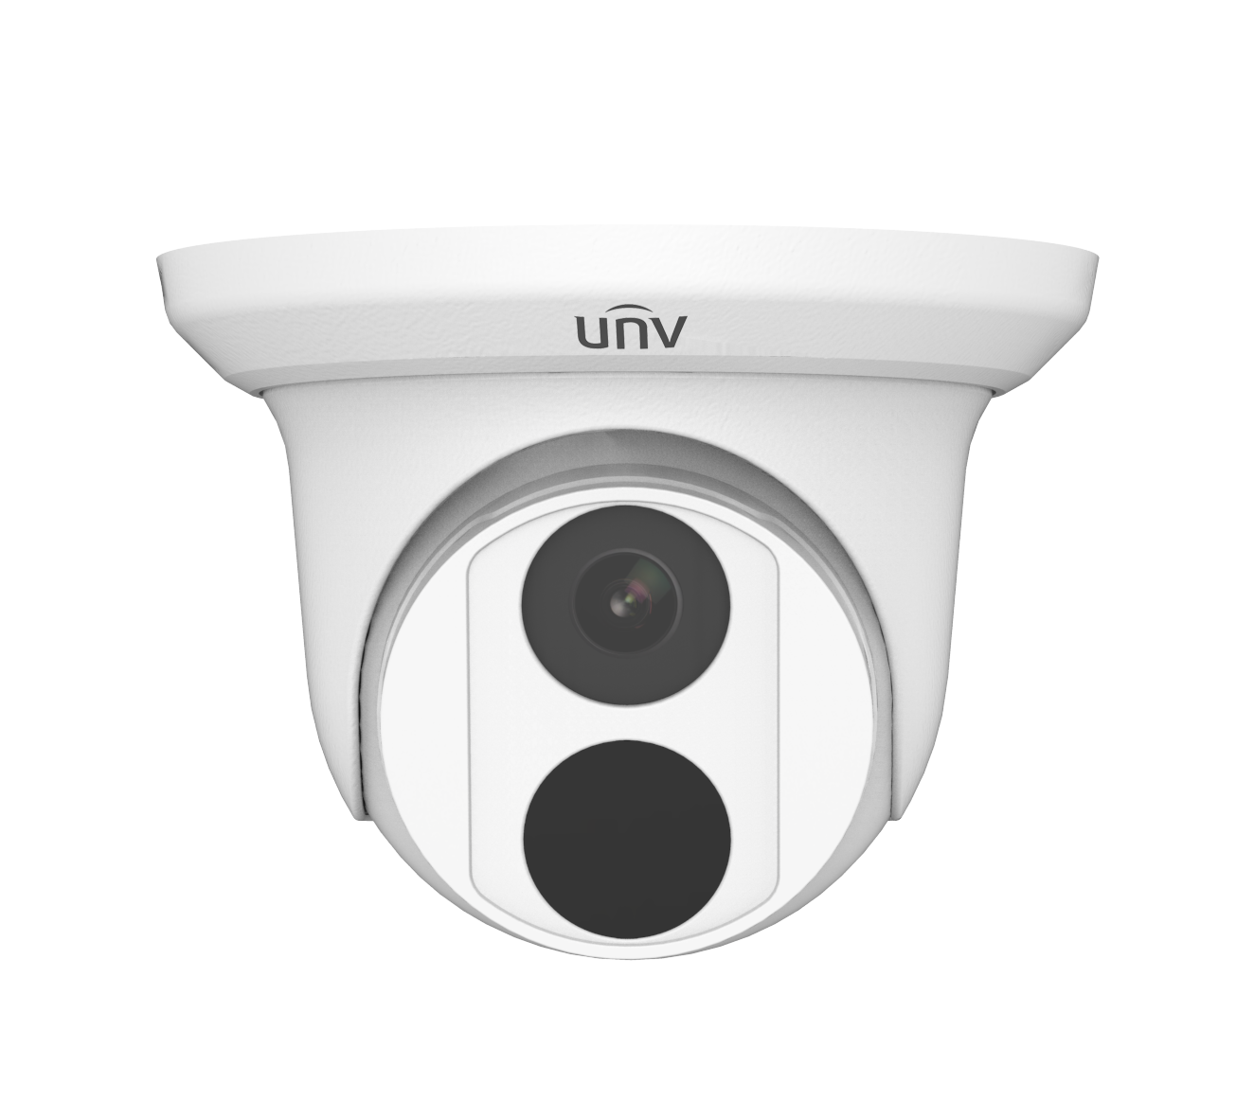

Key Features
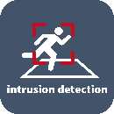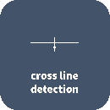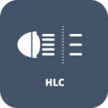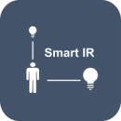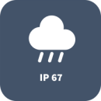

- High quality image with 4MP, 1/3"CMOS sensor
- 4MP (2560*1440)@25/20fps; 3MP (2304*1296)@30/25fps; 2MP (1920*1080)@30/25fps; 720P (1280*720)@30/25fps
- Ultra 265, H.265, H.264, MJPEG
- Smart IR, up to 30m (98ft) IR distance
- Supports 128 G Micro SD card
- Support PoE power supply
- 3-Axis

Specifications
 | EC-T4F28M
Camera
Sensor | 1/3", 4.0 megapixel, progressive scan, CMOS
Min. Illumination | Colour: 0.01Lux (F2.0, AGC ON)  0Lux with IR
Day/Night | IR-cut filter with auto switch (ICR)
Shutter | Auto/Manual, 1 ~ 1/100000s
Adjustment angle | Pan: 0° ~ 360° , Tilt: 0° ~ 75°, Rotate: 0° ~ 360°
S/N | >56dB
WDR | DWDR
Lens
Lens Type | 2.8mm and 4.0mm @2.0, Fixed-focal
Lens Mount | M12
Angle of View (H) | 97.0° |  |  | 79.0°
Angle of View (V) | 52.2° |  |  | 42.3°
Angle of View (O) | 107.5° |  |  | 85.1°
DORI
DORI Distance | Lens (mm) | Detect (m) | Observe (m) |  | Recognize (m) | Identify (m)
 | 2.8 | 63.0 | 25.2 |  | 12.6 | 6.3
 | 4.0 | 90.0 | 36.0 |  | 18.0 | 9.0
Illuminator
IR Range | Up to 30m (98ft) IR range
Wavelength | 850nm
IR On/Off Control | Auto/Manual
Video
Video Compression | Ultra 265, H.265, H.264, MJPEG
H.264 code profile | Baseline profile, Main profile, High profile
Frame Rate | Main Stream: 4MP (2560*1440), Max 25fps; 3MP (2304*1296), Max 30fps; 1080P (1920*1080), Max 30fps; 720P (1280*720), Max 30fps  Sub Stream:D1 (720*576), Max 30fps; 640*360,Max 30fps; 2CIF(704*288), Max 30fps; CIF(352*288), Max 30fps;
Video Bit Rate | 128 Kbps~6144 kbps
U-code | Supported
OSD | Up to 4 OSDs
Privacy Mask | Up to 4 areas
ROI | Up to 8 areas
Motion Detection | Up to 4 areas
Image
White Balance | Auto/Outdoor/Fine Tune/Sodium Lamp/Locked/Auto2
Image Setting | Image rotation, brightness, saturation, contrast, sharpness, gain adjustable by web browser
Digital noise reduction | 2D/3D DNR
Smart IR | Support
Flip | Normal/Vertical/Horizontal/180°
Dewarping | N/A
HLC | Supported
BLC | Supported
Defog | Digital Defog
Events
Behavior Detection | Cross line, intrusion(based on human body detection)
 | Motion detection, tampering alarm
General Function | Watermark, IP address filtering, access policy, ARP protection, RTSP authentication, user authentication
Storage
Edge Storage | Micro SD, up to 128GB
Network Storage | ANR, NAS(NFS)
Network
Protocols | IPv4, IGMP, ICMP, ARP, TCP, UDP, DHCP, RTP, RTSP, RTCP, RTMP, DNS, DDNS, NTP, FTP, UPnP, HTTP, HTTPS, SMTP, QoS, SSL/TLS, SNMP
Compatible Integration | ONVIF (Profile S, Profile G, Profile T), API , SDK
User/Host | Up to 32 users. 2 user levels: administrator and common user
Security | Password protection, Strong password, HTTPS encryption, Export operation logs, Basic and digest authentication for RTSP, Digest authentication for HTTP, TLS 1.2, WSSE and digest authentication for ONVIF
Client | EZStation  EZView  EZLive
Web Browser | Plug-in required live view: IE9+, Chrome 41 and below, Firefox 52 and below
 | Plug-in free live view: Chrome 57.0+, Firefox 58.0+, Edge 16+
Interface
Network | 1 * RJ45 10M/100M Base-TX Ethernet
Certification
EMC | FCC: FCC Part 15
Safety | CE: EN 60950-1  UL: UL60950-1  IEC 60950-1
General
Power | DC 12V±25%, PoE (IEEE 802.3af)
 | Power consumption: Max 4.0W
Power Interface | Ø 5.5mm coaxial power plug
Dimensions (Ø x H) | Φ118 x 97mm (Φ4.6” x 3.8”)
Weight | 0.30kg (0.66lb)
Material | Metal + Plastic
Working Environment | -30°C ~ 60°C (-22°F ~ 140°F), Humidity: ≤95% RH (non-condensing)
Storage Environment | -30°C ~ 60°C (-22°F ~ 140°F), Humidity: ≤95% RH (non-condensing)
Surge Protection | 4KV
Reset Button | N/A
Ingress Protection | Ingression protection: IP67

Dimensions
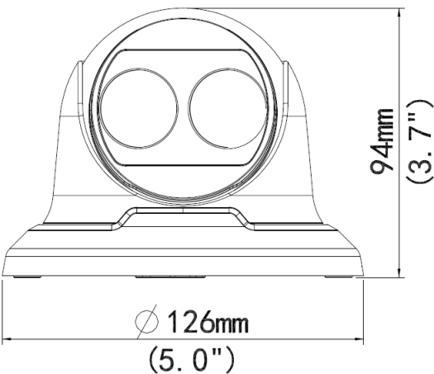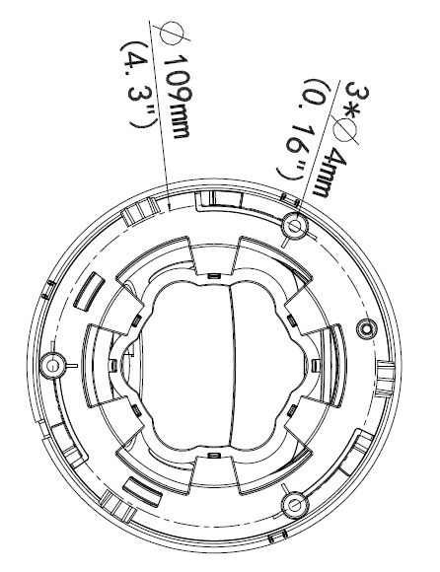

Accessories
TR-JB03-H-IN TR-JB07/WM03-F-IN TR-WM03-B-IN TR-UP06-IN TR-A01-IN
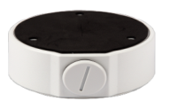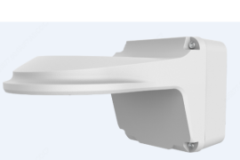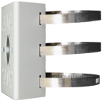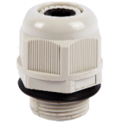

TR-SE24-IN TR-SE24-A-IN TR-CM24-IN

Zhejiang Uniview Technologies Co., Ltd.
Building No.10, Wanlun Science Park, Jiangling Road 88, Binjiang District, Hangzhou, Zhejiang, China (310051)
Email: overseasbusiness@uniview.com; globalsupport@uniview.com
http://www.uniview.com
©2020 Zhejiang Uniview Technologies Co., Ltd. All rights reserved.
*Product specifications and availability are subject to change without notice.

