EK-S31P8T46T2-V2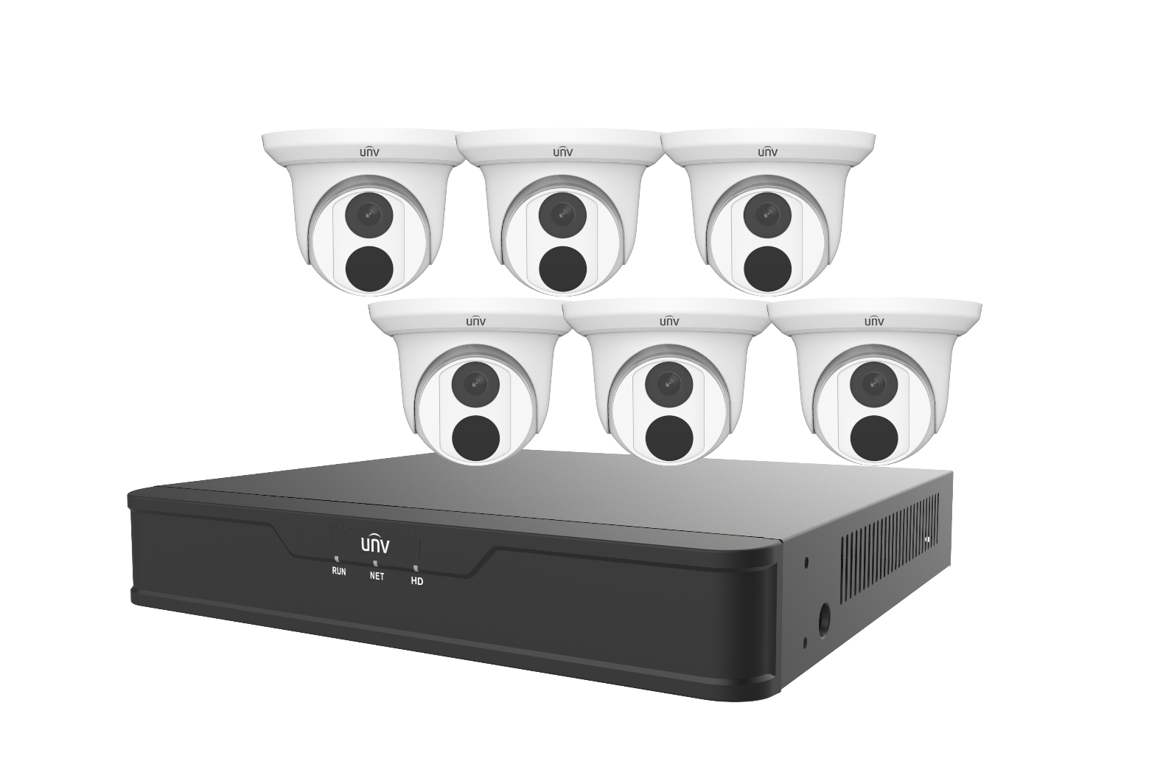

Key Features
NVR301-08S3-P8
- Support Ultra 265/H.265/H.264 video formats
- 8-channel input
- Plug & Play with 8 independent PoE network interfaces
- Third-party IP cameras supported with ONVIF conformance: Profile S, Profile G, Profile T
- Support 1-ch HDMI, 1-ch VGA
- HDMI and VGA simultaneous output
- Up to 8MP resolution recording
- 1 SATA HDD
- Support cloud upgrade

EC-T4F28M
- Day/night functionality
- Smart IR, up to 30 m (98 ft) IR distance
- 2D/3D DNR (Digital Noise Reduction)
- Ultra 265, H.265, H.264, MJPEG
- ROI (Region of Interest)
- ONVIF Conformance
- Wide temperature range: -30°C ~ +60°C (-22°F ~ 140°F)
- Wide voltage range of ±25%
- IP67

Specifications
Model | NVR301-08S3-P8
Video/Audio Input
IP Video Input | 8-ch
Network
Incoming Bandwidth | 64Mbps
Outgoing Bandwidth | 48Mbps
Remote Users | 128
Protocols | TCP/IP, P2P, UPnP, NTP, DHCP, PPPoE, HTTP, HTTPS, DNS, DDNS, SNMP, SMTP
Video/Audio Output
HDMI/VGA Output | HDMI:  3840x2160/30Hz,1920x1080p/60Hz, 1920x1080p/50Hz, 1600x1200/60Hz, 1280x1024/60Hz, 1280x720/60Hz, 1024x768/60Hz  VGA:  1920x1080p/60Hz, 1920x1080p/50Hz, 1600x1200/60Hz, 1280x1024/60Hz, 1280x720/60Hz, 1024x768/60Hz
Recording Resolution | 4K/5MP/4MP/3MP/1080p/960p/720p/D1/2CIF/CIF
Audio Output | 1-ch, RCA
Audio Compression | G.711A, G.711U
Synchronous Playback | 8-ch
Corridor Mode Screen | 3/4/5/7/9
Decoding
Decoding format | Ultra 265/H.265/H.264
Liveview/Playback | 4K/5MP/4MP/3MP/1080p/960p/720p/D1/2CIF/CIF
Capability | 1 x 4k@30, 1 x 5MP@30, 2 x 4MP@30, 4 x 3MP@25, 4 x 1080p@30, 8 x 720p@30
Hard Disk
SATA | 1 SATA interface
Capacity | up to 8TB for each disk
Smart
VCA Detection by Camera | Face detection, Intrusion detection, Cross line detection, Audio detection, Enter Area, Leave Area
VCA Search | Face Search, Behavior Search
External Interface
Network Interface | 1 RJ-45 10M/100Mself-adaptive Ethernet Interface
USB Interface | Rear panel: 2 x USB2.0
PoE
Interface | 8 RJ45 10M/100M self-adaptive Ethernet Interface
Max Power | Max 30W for single port  Max 75W in total
Supported Standard | IEEE 802.3at, IEEE 802.3af
General
Power Supply | 52V DC  Power Consumption: ≤9 W (without HDD)
Working Environment | -10°C ~ + 55°C (+14°F ~ +131°F), Humidity ≤ 90% RH (non-condensing)
Dimensions (W×D×H) | 260mm ×240mm × 46 mm (10.2" × 9.4" ×1.8")
Weight (without HDD) | ≤1.1kg (2.43lb)
Model | EC-T4F28M
Camera
Sensor | 1/3", 4.0 megapixel, progressive scan, CMOS
Min. Illumination | Colour: 0.01Lux (F2.0, AGC ON)  0Lux with IR
Day/Night | IR-cut filter with auto switch (ICR)
Shutter | Auto/Manual, 1 ~ 1/100000s
Adjustment angle | Pan: 0° ~ 360° , Tilt: 0° ~ 75°, Rotate: 0° ~ 360°
S/N | >56dB
WDR | DWDR
Lens
Lens Type | 2.8mm @2.0, Fixed-focal
Lens Mount | M12
Angle of View (H) | 97.0°
Angle of View (V) | 52.2°
Angle of View (O) | 107.5°
DORI
DORI Distance | Lens (mm) | Detect (m) | Observe (m) | Recognize (m) | Identify (m)
 | 2.8 | 63.0 | 25.2 | 12.6 | 6.3
Illuminator
IR Range | Up to 30m (98ft) IR range
Wavelength | 850nm
IR On/Off Control | Auto/Manual
Video
Video Compression | Ultra 265, H.265, H.264, MJPEG
H.264 code profile | Baseline profile, Main profile, High profile
Frame Rate | Main Stream: 4MP (2560*1440), Max 25fps; 3MP (2304*1296), Max 30fps; 1080P (1920*1080), Max 30fps; 720P (1280*720), Max 30fps  Sub Stream:D1 (720*576), Max 30fps; 640*360,Max 30fps; 2CIF(704*288), Max 30fps; CIF(352*288), Max 30fps;
Video Bit Rate | 128 Kbps~6144 kbps
U-code | Supported
OSD | Up to 4 OSDs
Privacy Mask | Up to 4 areas
ROI | Up to 8 areas
Motion Detection | Up to 4 areas
Image
White Balance | Auto/Outdoor/Fine Tune/Sodium Lamp/Locked/Auto2
Image Setting | Image rotation, brightness, saturation, contrast, sharpness, gain adjustable by web browser
Digital noise reduction | 2D/3D DNR
Smart IR | Support
Flip | Normal/Vertical/Horizontal/180°
Dewarping | N/A
HLC | Supported
BLC | Supported
Defog | Digital Defog
Events
Behavior Detection | Cross line, intrusion(based on human body detection)
 | Motion detection, tampering alarm
General Function | Watermark, IP address filtering, access policy, ARP protection, RTSP authentication, user authentication
Storage
Edge Storage | Micro SD, up to 128GB
Network Storage | ANR, NAS(NFS)
Network
Protocols | IPv4, IGMP, ICMP, ARP, TCP, UDP, DHCP, RTP, RTSP, RTCP, RTMP, DNS, DDNS, NTP, FTP, UPnP, HTTP, HTTPS, SMTP, QoS, SSL/TLS, SNMP
Compatible Integration | ONVIF (Profile S, Profile G, Profile T), API , SDK
User/Host | Up to 32 users. 2 user levels: administrator and common user
Security | Password protection, Strong password, HTTPS encryption, Export operation logs, Basic and digest authentication for RTSP, Digest authentication for HTTP, TLS 1.2, WSSE and digest authentication for ONVIF
Client | EZStation  EZView  EZLive
Web Browser | Plug-in required live view: IE9+, Chrome 41 and below, Firefox 52 and below
 | Plug-in free live view: Chrome 57.0+, Firefox 58.0+, Edge 16+
Interface
Network | 1 * RJ45 10M/100M Base-TX Ethernet
Certification
EMC | FCC: FCC Part 15
Safety | CE: EN 60950-1  UL: UL60950-1  IEC 60950-1
General
Power | DC 12V±25%, PoE (IEEE 802.3af)
 | Power consumption: Max 4.0W
Power Interface | Ø 5.5mm coaxial power plug
Material | Metal
Working Environment | -30°C ~ 60°C (-22°F ~ 140°F), Humidity: ≤95% RH (non-condensing)
Storage Environment | -30°C ~ 60°C (-22°F ~ 140°F), Humidity: ≤95% RH (non-condensing)
Surge Protection | 4KV
Reset Button | N/A
Ingress Protection | Ingression protection: IP67

Dimensions
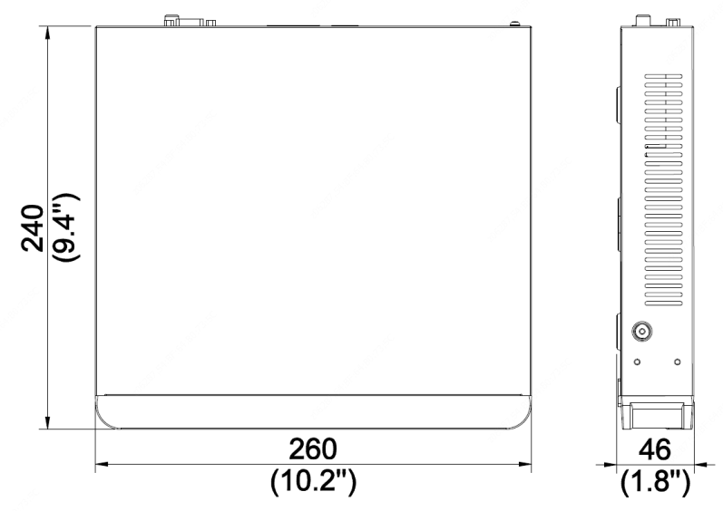
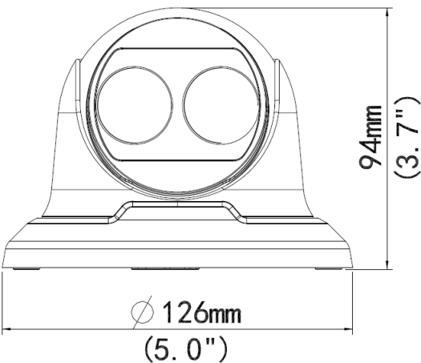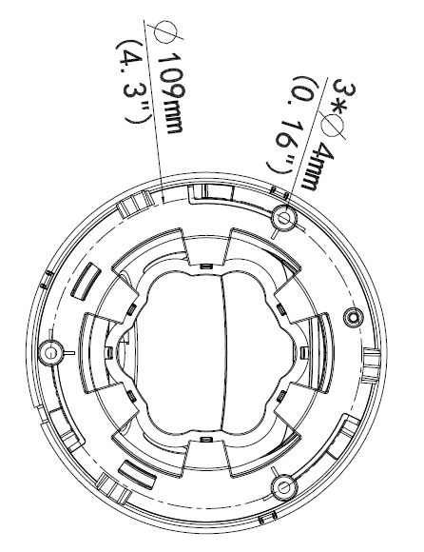
Zhejiang Uniview Technologies Co., Ltd.
Building No.10, Wanlun Science Park, Jiangling Road 88, Binjiang District, Hangzhou, Zhejiang, China
Email: overseasbusiness@uniview.com; globalsupport@uniview.com
http://www.uniview.com
©2019 Zhejiang Uniview Technologies Co., Ltd. All rights reserved.
- Product specifications and availability are subject to change without notice.

