16MP LightHunter 180° OmniView Network Camera

IPC8544EA-KM-I1

Key Features
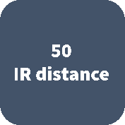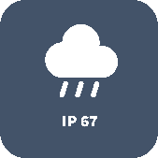
- High quality image with 16MP, 1/1.8’’ CMOS sensor
- 4800*2688@30fps in the main stream offers 180° panoramic view, and 16:9 ratio can better fit the screen
- Smart IR, up to 50m (164 ft) IR distance
- Built-in fan, allows dissipating heat and eliminating the mist of window
- Ultra 265,H.265, H.264, MJPEG
- 2D/3D DNR (Digital Noise Reduction)
- AC24V, DC24V or PoE(IEEE 802.3at) power supply
- Micro SD, up to 256 GB
- Alarm 2 in and 1 out, Audio 1 in and 1 out
- IP67 ingress protection

Specifications
 | IPC8544EA-KM-I1
Camera
Sensor | 1/1.8" progressive scan, 4.0 megapixel, CMOS
Min. Illumination | Colour: 0.001lux (F1.6,AGC ON)  0lux with IR
Day/Night | IR-cut filter with auto switch (ICR)
Shutter | Auto/Manual, shutter time: 1 s ~ 1/100000 s
WDR | Digital WDR
S/N | >56dB
Lens
Lens | 4×2.8mm lens
Iris | F1.6
Field of View (H) | 180°
Field of View (V) | 90°
Field of View (D) | 221.4°
DORI
DORI Distance | Lens (mm) | Detect (m) | Observe (m) | Recognize (m) | Identify (m)
 | 2.8 | 63.0(206.7ft) | 25.2(82.7ft) | 12.6(41.3ft) | 6.3(20.7ft)
Illuminator
IR Range | Up to 50m (164ft) IR range
Wavelength | 850nm
IR On/Off Control | Auto/Manual
Video
Video Compression | Ultra 265, H.265, H.264, MJPEG
Frame Rate | Main Stream: 4800×2688:Max. 30 fps;  Sub Stream: 2688×1520:Max. 30 fps;  Third Stream: 1280×720: Max. 30 fps;
Video Bit Rate | 128 Kbps~16 Mbps
ROI | Up to 8 areas
Video stream | Triple streams
OSD | Up to 8 OSDs
Privacy Mask | Up to 8 areas(8 blacks/8 mosaics)
Image
White Balance | Auto/Outdoor/Fine Tune/Sodium Lamp/Locked/Auto2
Digital noise reduction | 2D/3D DNR
Smart IR | Support
Flip | Normal/Flip Vertical/Flip Horizontal/180°
HLC | Support
BLC | Support
Defog | Digital Defog
Events
General Function | Watermark, IP Address Filtering, Tampering Alarm, Alarm input, Alarm output, Access Policy, ARP Protection, RTSP Authentication, User Authentication
Audio
Audio Compression | G.711U, G.711A
Two-way Audio | Supported
Suppression | Supported
Sampling Rate | 8KHz
Storage
Edge Storage | Micro SD, up to 256 GB
Network Storage | ANR,NAS(NFS)
Network
Protocols | IPv4, IGMP, ICMP, ARP, TCP, UDP, DHCP, PPPoE, RTP, RTSP, RTCP, DNS, DDNS, NTP, FTP, UPnP, HTTP, HTTPS, SMTP, 802.1x, SNMP, QoS, RTMP
Compatible Integration | ONVIF (Profile S, Profile G, Profile T), API
Client | EZStation  EZLive  EZView
Web Browser | Plug-in required live view: IE9+, Chrome 41 and below, Firefox 52 and below
Interface
Audio I/O | Audio cable
 | 1 Input: impedance 35kΩ; amplitude 2V [p-p]
 | 1 output: impedance 600Ω; amplitude 2V [p-p]
Alarm I/O | 2/1
Network | 10M/100M/1000M Base-TX Ethernet
Certification
EMC | CE-EMC (EN 55032: 2015+A1:2020,EN 61000-3-3: 2013+A1: 2019,EN IEC 61000-3-2: 2019+A1: 2021,EN 55035: 2017+A11:2020)  FCC (FCC CFR 47 part15 B, ANSI C63.4-2014)
Safety | CE LVD (EN 62368-1:2014+A11:2017)  CB (IEC 62368-1:2014)  UL (UL 62368-1, 2nd Ed., Issue Date: 2014-12-01)
Environment | CE-RoHS (2011/65/EU;(EU)2015/863); WEEE (2012/19/EU); Reach (Regulation (EC) No 1907/2006)
Protection | IP67 (IEC 60529:1989+AMD1:1999+AMD2:2013)
General
Power | AC24V±25%/DC24V±25%, PoE(IEEE 802.3at)
 | Power consumption: Max 34W
Dimensions (Ø x H) | 258.8mmx211.0mmx115.0mm(10.2”×8.3”×4.5”)
Weight | 2.271kg(5.01lb)
Working Environment | –40°C ~ +70°C (-40°F ~ 158°F), Humidity: ≤95%RH RH(non-condensing)
Storage Environment | –40°C ~ +70°C (-40°F ~ 158°F), Humidity: ≤95%RH RH(non-condensing)
surge protection | 6KV

Dimensions
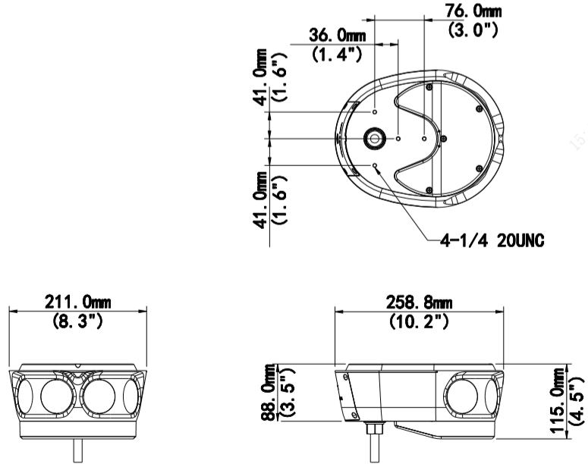

Accessories

TR-WE45-D-IN TR-JB07-D-IN TR-CM06-C-IN TR-UV06-C-IN
Wall Mount Junction Box Pendant mount 2D Bracket Mount
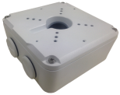

TR-UP06-IN TR-UP06-B-IN
Pole Mount Pole Mount
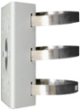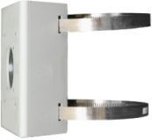

Junction Mount | Pole Mount
TR-WE45-D-IN + TR-JB07-D-IN | TR-WE45-D-IN + TR-UP06-B-IN
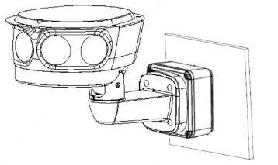 | 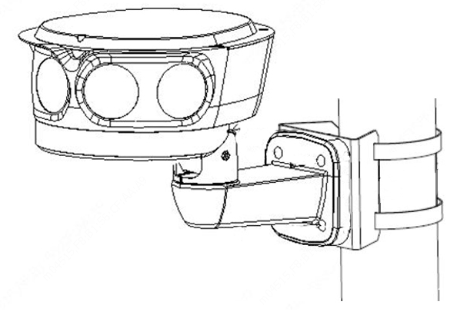
Pendent Mount | Horizontal Pole Mount
TR-CM06-C-IN | TR-UV06-C-IN+ TR-UP06-IN
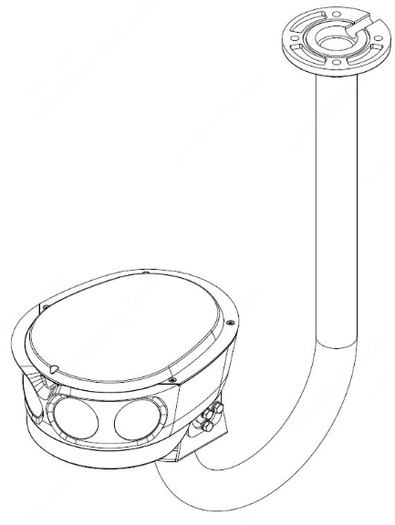 | 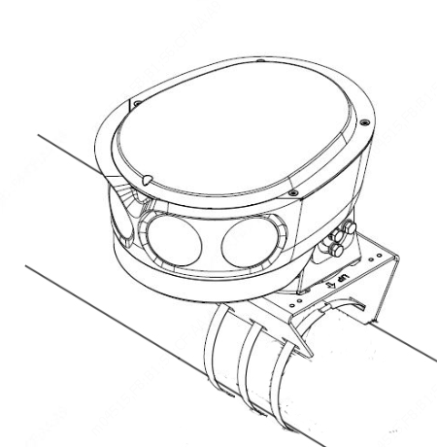

Zhejiang Uniview Technologies Co., Ltd.
Building No.10, Wanlun Science Park, Jiangling Road 88, Binjiang District, Hangzhou, Zhejiang, China (310051)
Email: overseasbusiness@uniview.com; globalsupport@uniview.com
http://www.uniview.com
©2023 Zhejiang Uniview Technologies Co., Ltd. All rights reserved.
*Product specifications and availability are subject to change without notice

