DX204 Quad-Core 4-HDD NAS
DX204
DX204 is an enterprise-grade, high-performance 4-HDD NAS network storage server launched by Uniview for private cloud. It is equipped with Intel quad-core processor, dual M.2 SSD interfaces, and dual GbE interfaces to provide high-speed access performance and faster transmission experience. The product offers an efficient and reliable solution to massive data storage, file sharing, data protection, and remote autonomous access, making a perfect choice for small and medium-sized enterprises and individual users.
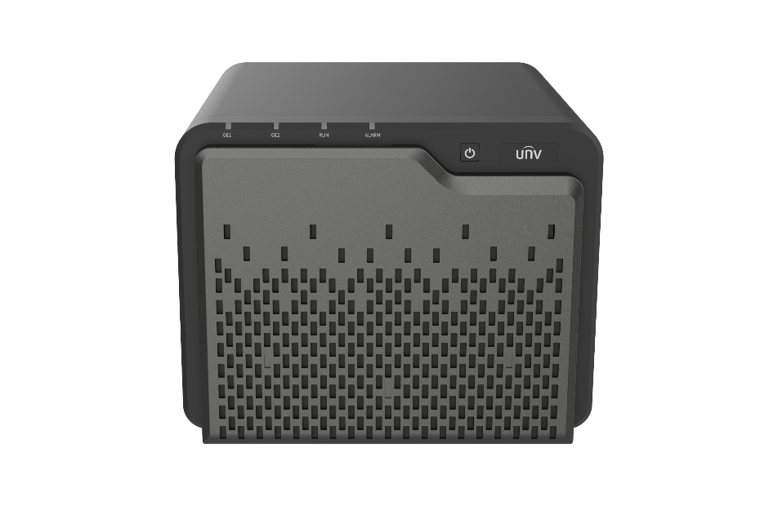

Features
- Supports snapshot, offers effective protection for important data against crypto ransomware.
- Supports high-level data security, AES enterprise-grade encryption, SSL security certificates, and disaster recovery protection.
- Supports log management, allows user to view file access logs.
- Supports multiple file sharing protocols including ISCSI, NFS, AFP, SMB, FTP, WEBDAV.
- Supports flexible permission management and multi-layer protection mechanism.
- Supports smart O&M, advanced device and HDD health monitoring, alert users of potential risks of data loss.
- Supports RAID technology, allows the configuration of one or more backup HDDs.
- High-speed transmission, supports 10Gigabit network interface card.

Video Functions
- Remote access to view live and recorded video anytime.
- Centralized video data storage.
- Supports access of multiple cameras and real-time video viewing.
- Supports centralized device management with rich camera support.
- Enhanced data security with AES encryption to protect video privacy and restrict access permissions.

Specifications
Model | DX204
OS | Ubuntu 5.4
CPU | Intel quad-core X86_64 processor
RAM | 4GB DDR4, dual SO-DIMM slots, expandable to 32GB
HDD | 4 * SATA3.0 slots, compatible with 3.5-inch or 2.5-inch SATA HDD/SSD(Single HDD up to 20TB capacity)
Network interface | 2*GE, 1*PCIe 3.0 for expansion to 10Gigabit network
M.2 HDD slot | 2 (NVMe)
EMMC | 8GB (standard)
Video storage performance | 64*2Mbps
Access protocol | Supports Onvif cameras.
Dimensions | 246mm (L) × 226mm (W) × 186mm (H)
Weight | 3.6 kg (without HDD)
Power consumption | 33W (with HDD fully configured)
Noise | Room temperature 25°C≤20dB  Within the environment’s highest specified limit ≤23dB (low power operation mode)
Operating temperature | 0°C to +45°C
Storage temperature | -20°C to +70°C
Operating humidity | 5% to 95% (non-condensing)
Storage humidity | 5% to 95% (non-condensing)

Dimensions

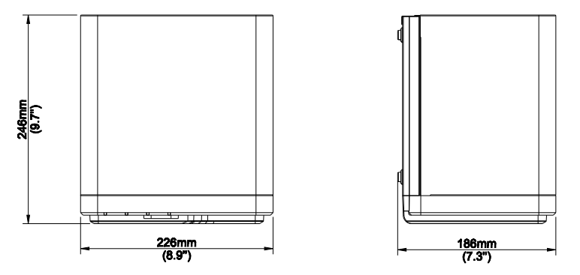

Ordering Information
Model | Description | Remarks
DX204 | Assembling component-UNV-DX204-4 HDD desktop NAS(4GB)-Overseas version | DX204 Quad-Core 4-HDD NAS Network Storage Server

Zhejiang Uniview Technologies Co., Ltd.
No. 369, Xietong Road, Xixing Sub-district, Binjiang District, Hangzhou City, 310051, Zhejiang Province, China
Email: overseasbusiness@uniview.com; globalsupport@uniview.com
http://www.uniview.com
©2023 Zhejiang Uniview Technologies Co., Ltd. All rights reserved.
*Product specifications and availability are subject to change without notice.

