4MP HD Intelligent LightHunter IR Fixed Dome Network Camera
IPC324SS-ADF28(40)K-I1

Key Features
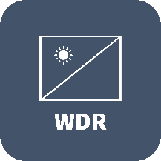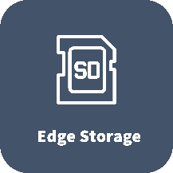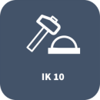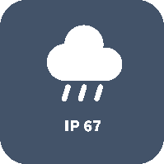

- High quality image with 4MP, 1/3"CMOS sensor
- 4MP (2688*1520)@ 30/25(default)fps; 4MP (2560*1440)@ 30/25fps; 3MP (2304*1296) @ 30/25fps; 2MP (1920*1080) @30/25fps;
- Ultra 265, H.265, H.264, MJPEG
- Intelligent perimeter protection, include cross line, intrusion, enter area, leave area detection
- Based on target classification, smart intrusion prevention significantly reduce false alarm caused by leaves, birds and lights etc., accurately focus on human and, motor vehicle and non-motor vehicle
- Intelligent face capture
- Intelligent People Flow Counting and Crowd Density Monitoring
- Auto Scene Match (ASM)（Only WDR）
- LightHunter technology ensures ultra-high image quality in low illumination environment
- 130dB true WDR technology enables clear image in strong light scene
- Support 9:16 Corridor Mode
- Alarm:1 in/1 out, Audio: 1 in/1 out
- Smart IR, up to 40m (131ft) IR distance
- Supports 256 G Micro SD card
- IK10 vandal resistant and IP67 protection

Specifications
 | IPC324SS-ADF28K-I1 |  |  |  | IPC324SS-ADF40K-I1
Camera
Sensor | 1/3", 4.0 megapixel, progressive scan, CMOS
Minimum Illumination | Colour: 0.002Lux (F1.6, AGC ON)  0 lux with IR
Day/Night | IR-cut filter with auto switch (ICR)
Shutter | Auto/Manual, 1 ~ 1/100000s
Adjustment angle | Pan: 0° ~ 352° |  | Tilt: 0° ~ 70° |  |  |  |  | Rotate: 0° ~ 350°
WDR | 130dB
S/N | >56dB
Lens
Lens | 2.8mm@F1.6 |  |  |  |  | 4.0mm@F1.6
Iris | Fixed
Field of View (H) | 97.68° |  |  |  |  | 81.39°
Field of View (V) | 52.67° |  |  |  |  | 43.36°
Field of View (D) | 102.52° |  |  |  |  | 86.91°
DORI
DORI Distance | Lens (mm) | Detect (m) |  | Observe (m) |  |  | Recognize (m) |  | Identify (m)
 | 2.8 | 63.0 |  | 25.2 |  |  | 12.6 |  | 6.3
 | 4.0 | 90.0 |  | 36.0 |  |  | 18.0 |  | 9.0
Illuminator
IR Range | Up to 40m (131ft) IR range
Wavelength | 850nm
IR On/Off Control | Auto/Manual
Video
Video Compression | Ultra 265, H.265, H.264, MJPEG
H.264 code profile | Baseline profile, Main profile, High profile
Frame Rate | Main Stream: 4MP (2688*1520), Max 30fps;4MP (2560*1440), Max 30fps; 3MP (2304*1296), Max 30fps; 1080P (1920*1080), Max 30fps;  Sub Stream: 1080P (1920*1080), Max 30fps; 720P (1280*720), Max 30fps; D1 (720*576), Max 30fps; 640*360, Max 30fps; 2CIF(704*288), Max 30fps; CIF(352*288), Max 30fps;  Third Stream: D1 (720*576), Max 30fps; 640*360,Max 30fps; 2CIF(704*288), Max 30fps; CIF(352*288), Max 30fps;
Video Bit Rate | 128 Kbps~16 Mbps
U-code | Support
OSD | Up to 8 OSDs
Privacy Mask | Up to 4 areas
ROI | Up to 8 areas
Video Stream | Triple streams
Image
White Balance | Auto/Outdoor/Fine Tune/Sodium Lamp/Locked/Auto2
Digital Noise Reduction | 2D/3D DNR
Smart IR | Support
Flip | Normal/Vertical/Horizontal/180°/90°Clockwise/90°Anti-clockwise
Dewarping | N/A
HLC | Support
BLC | Support
Defog | Digital Defog
Intelligent
Smart intrusion prevention | Support false alarm filtering: Cross Line detection, Intrusion detection, Enter Area detection, Leave Area detection
Recognition | Face capture
Statistical Analysis | People counting, support people flow counting and crowd density monitoring
Auto Scene Match (ASM) | Support（Only WDR）
Events
Basic Detection | Motion detection, Ultra motion detection, Tampering alarm, Audio detection
General Function | Watermark, IP address filtering, alarm input, alarm output, access policy, ARP Protection, RTSP authentication, user authentication
Audio
Audio Compression | G.711U, G.711A
Audio Bitrate | 64 Kbps
Two-way audio | Support
Suppression | Support
Sampling Rate | 8KHZ
Storage
Edge Storage | Micro SD, up to 256GB
Network Storage | ANR, NAS(NFS)
Network
Protocols | IPv4, IPv6, IGMP, ICMP, ARP, TCP, UDP, DHCP, PPPoE, RTP, RTSP, RTCP, DNS, DDNS, NTP, FTP, UPnP, HTTP, HTTPS, SMTP, 802.1x, SNMP, QoS, RTMP,SSL/TLS, SSH
Compatible Integration | ONVIF (Profile S, Profile G, Profile T), API,SDK
User/Host | Up to 32 users. 3 user levels: administrator, common user and operator
Security | Password protection, Strong password, HTTPS encryption, Export operation logs, Basic and digest authentication for RTSP, Digest authentication for HTTP, TLS 1.2, WSSE and digest authentication for ONVIF
Client | EZStation  EZView  EZLive
Web Browser | Plug-in required live view: IE 10 and above, Chrome 45 and above, Firefox 52 and above, Edge 79 and above
 | Plug-in free live view: Chrome 57.0 and above, Firefox 58.0 and above, Edge 16 and above
Interface
Audio I/O | Input: impedance 35kΩ; amplitude 2V [p-p]
 | Output: impedance 600Ω; amplitude 2V [p-p]
Alarm I/O | 1/1
RS485 | N/A
Built-in Mic | Support
Built-in Speaker | N/A
WIFI | N/A
Network | 1 * RJ45 10M/100M Base-TX Ethernet
Video Output | N/A
Certifications
EMC | CE-EMC (EN 55032,EN 61000-3-3,EN IEC 61000-3-2,EN 50130)  FCC (FCC 47 CFR part15 B)
Safety | CE-LVD (EN 62368-1)  CB (IEC 62368-1)  UL/CUL (UL 62368-1, CAN/CSA C22.2 No. 62368-1)
Environment | CE-RoHS (2011/65/EU;(EU)2015/863); WEEE (2012/19/EU)
Protection | IP67 (IEC 60529)  IK10 (IEC 62262)
General
Power | DC 12V±25%, PoE (IEEE 802.3af)
 | Power consumption: 6.5W
Power Interface | Ø 5.5mm coaxial power plug
Dimensions (Ø x H) | Φ111 x 83mm (Ø4.4” x 3.3”)
Weight | 0.42kg (0.93lb)
Material | Metal
Working Environment | -30°C ~ 60°C (-22°F ~ 140°F), Humidity: ≤95% RH (non-condensing)
Strorage Environment | -30°C ~ 60°C (-22°F ~ 140°F), Humidity: ≤95% RH (non-condensing)
Surge Protection | 4KV
Reset Button | Support
Web Client Language | 20 Languages  Traditional Chinese, English, Simplified Chinese, Polish, German, Russian, French, Korean, Dutch, Czech, Portuguese (Europe), Portuguese (Brazil), Japanese, Thai, Turkish, Spanish (Latin America), Spanish (Europe), Hungarian, Italian, Vietnamese

Dimensions
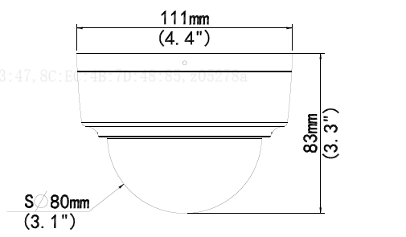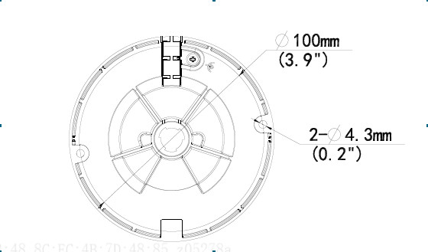

Accessories
TR-JB03-G-IN | TR-JB07/WM03-G-IN | TR-WM03-D-IN | TR-UM06-E-IN
Junction Box | Wall Mount | Wall Mount | cline Ceiling Mount
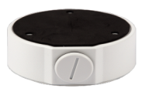 | 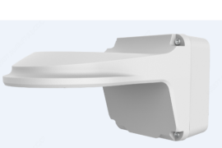 | 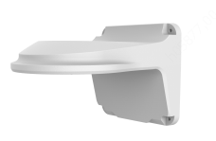 | 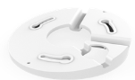
TR-UP06-IN | TR-A01-IN | TR-SE24-IN | TR-SE24-A-IN
Pole Mount | Waterproof Joint | Pendant Mount | Pendant Mount
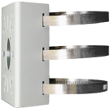 | 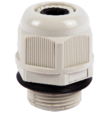
TR-CM24-IN | TR-UC08-C
Pendant Mount | Pole Mount

Junction Mount | Pole Mount
TR-JB03-G-IN | TR-JB07/WM03-G-IN
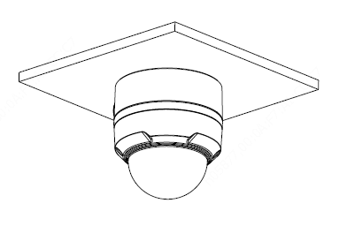 | 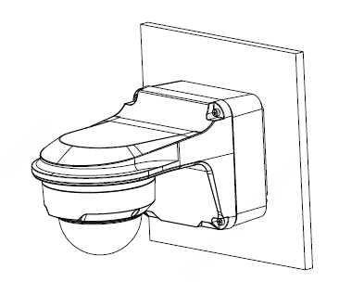
TR-UM06-E-IN | TR-JB07/WM03-G-IN+TR-UP06-IN
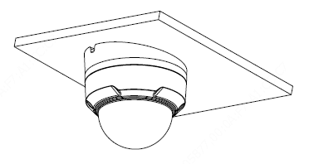 | 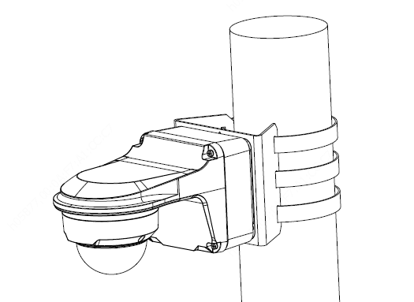
TR-CM24-IN+TR-JB03-G-IN | TR-JB07/WM03-G-IN+ TR-UC08-C
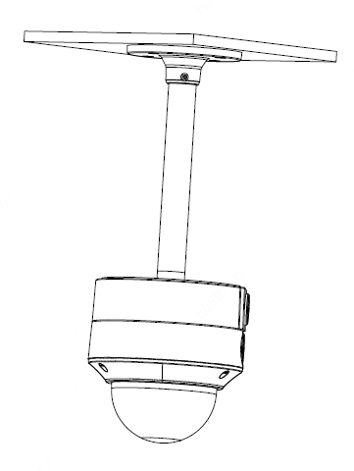 | 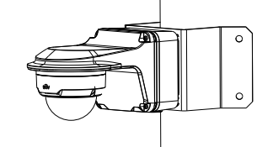

Zhejiang Uniview Technologies Co., Ltd.
Building No. 369, Xietong Road, Xixing Sub-district, Binjiang District, Hangzhou City, Zhejiang Province, China，310051
Email: overseasbusiness@uniview.com; globalsupport@uniview.com
http://www.uniview.com
©2023 Zhejiang Uniview Technologies Co., Ltd. All rights reserved.
*Product specifications and availability are subject to change without notice.

