IP Speaker
IP Horn speaker
SIP-S21M

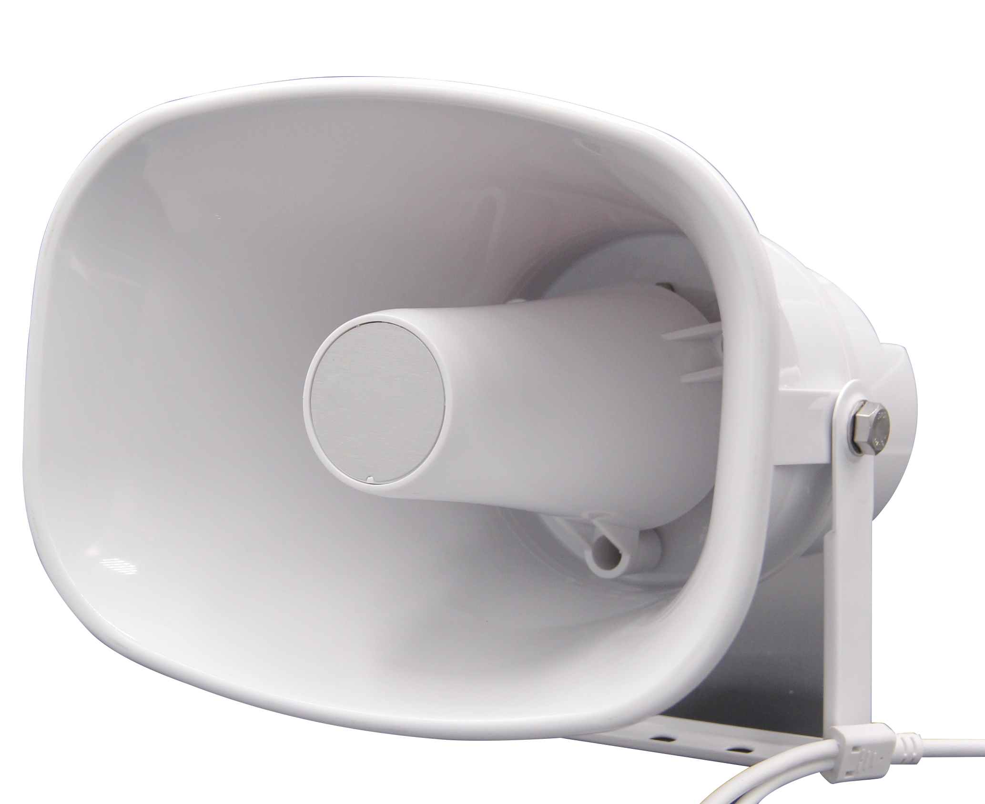

IP Speaker
Overview
IP horn speaker SIP-S21M with build in 30w amplifier is designed to be easy
installed for outdoor environment, it is well compatible with SIP & ONVIF
protocol that to be used in VoIP and Onvif VMS also NVR for security field. Up
to 10 RTP multicast address enable to arrange different paging solutions. Alarm
in and HTTP URL are able to combine with alarm system. Pre-recorded
message and schedule broadcasting to meet various paging demands.
The 48K OPUS Audio Codec enables excellent sound quality to make
announcement, play background music, security alarm in school, factory and
hospital, etc.
1. Two-Way Intercom Communication.
2. 48K OPUS, AEC, AGC, ANR
3. Compatible with VoIP, SIP devices (IPPBX, IP Phone) via SIP.
4. Compatible with IP Camera VMS via ONVIF.
5. HTTP Control, Alarm in, Schedule
6. 30W Amplifier, PoE Power Supply
7. Built-in MIC, Audio in

IP Speaker
Dimension
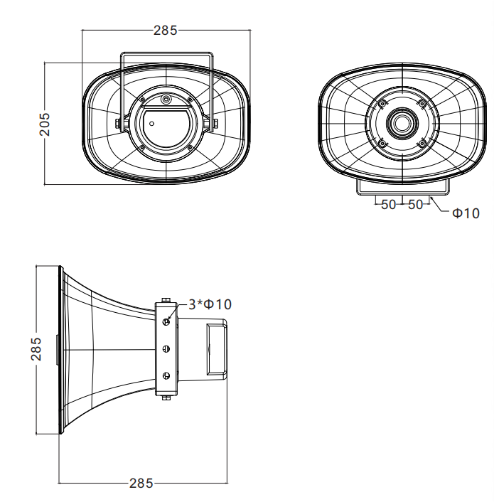
Cable Interface
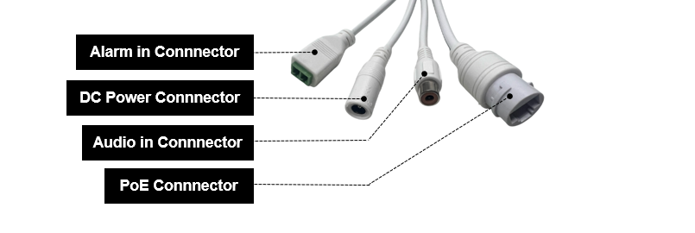
1. Alarm in Connector: Max 3.3V, Prerecorded play, SIP call and Http Stream Enable 2. PoE connector: RJ45
3. DC power Connector: 12-24V
4. Audio in: Top priority of all audio source like RTP multicast, SIP paging.

IP Speaker
Specification
Audio
Codec | OPUS 48KHz, MP3 44.1KHz, G.722 ADPCM 16KHz, G.711U 8KHz, G.711A 8KHz,  GSM, LPCM Stereo 44.1KHz, LPCM Mono 44.1KHz
Built-in  Microphone | Yes
Speaker
Max SPL | 120dB
Frequency  Response | 350Hz~8KHz
Frequency  Range | 500-2KHZ +-10dB  400-12KHZ +-20dB
Harmonic  Distortion | 0.1@1kHz
Signal to  Noise Ratio | 91dB
Network
Security: | Password protection, IP address filtering, Digest authentication, firewall
Network  Protocol | SIP, SIP P2P, ONVIF, HTTP, HTTPS, IPv4, DHCP, RTSP, RTP, RTCP, TCP, UDP,  ARP, NTP
Network  Interface | 10/100 Base-TX, RJ45
VoIP | Support for SIP protocol for integration with VoIP systems, integrated with SIP/PBX.  2 SIP Accounts  SIP Direct IP Call SIP P2P  Codec: OPUS, G.722, G.711U, G.711A
Amplifier
Amplifier  Description | Built-in 30W Amplifier
General
Operating  Temperature | -30℃ - +60℃
Storage  Temperature | -40℃ - +70℃
Operating  humility | 5% - 85%
Material | ABS (IP66 water-proof)
Rate Power | 30W
PoE | 802.3at
Power Supply | DC 12V/3A, 24V/2A
Connector | Alarm in, Audio in, DC Power, PoE

IP Speaker
Dimensions | 285*205*285mm
Net Weight | 2 KG

Software
Date/Time | Local time, NTP
Network | DHCP, Static IP Address
Onvif | Profile S
SIP Account | Support 2 SIP account registration
Audio | Codec： OPUS, G.722, G.711U, G.711A  Speaker out: Volume adjustment, Amp auto off setting, Jitter Buffer, HPR  and NR adjustment  Build in Mic: Volume adjustment, Gain, AEC, AGC, HPR and NR  adjustment
Media File | 5 embedded belling, 10 customized uploads (free space about 4MByte)
Alarm | Support prerecorded playing, SIP call, Http Stream URL, Http URL
Schedule | 10 schedule setting
RTP | 10 RTP multicasting
Firewall | Enable to config via IP/MAC, Automatic Defense
Auto Provision | DHCP Option, PnP, Static Provisioning Server (TFTP, FTP, HTTP)
System | Enable for reboot, reset, and FW upgrade, also user account and  passcode change

IP Speaker
Accessories
1. PoE waterproof connector
2. Quick Guide (Customized or White label)
A5 size, folded in half
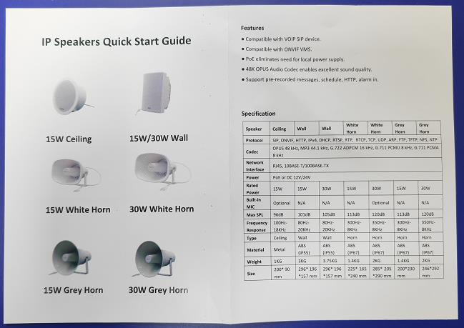

IP Speaker
Packing
1. Individual box
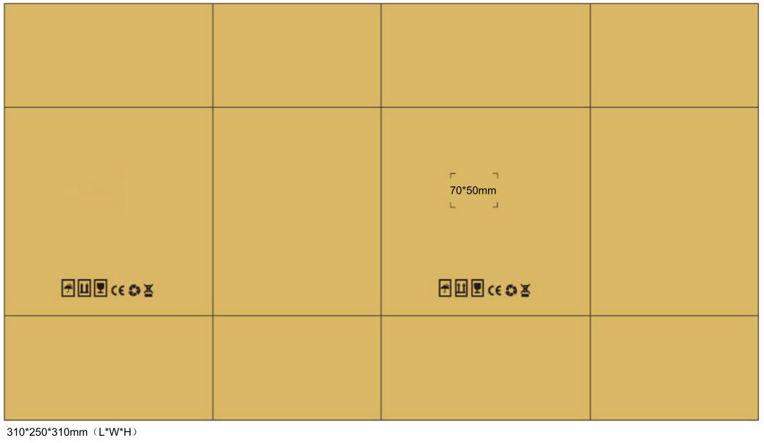
2. Outer box（4pcs）
