8MP HD ColorHunter With Smart Dual Light Fixed Turret Network Camera
E1T-8F28-DL
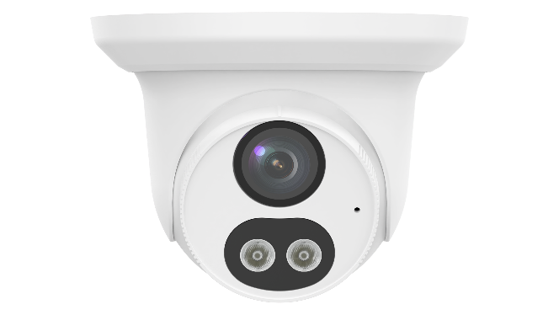

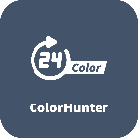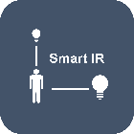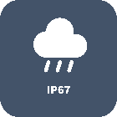

Features
- High quality image with 8 MP, 1/2.7" CMOS sensor
- 8 MP (3840 × 2160)@20 fps; 5 MP (3072 × 1728)@30/25 fps; 4 MP (2560 × 1440)@30/25 fps; 1080P (1920 × 1080)@30/25 fps
- Ultra 265, H.265, H.264, MJPEG
- 120 dB true WDR technology enables clear image in strong light scene
- Supports 9:16 corridor mode
- Built-in mic
- Smart IR, up to 30 m (98.4 ft.) IR distance
- MicroSD, up to 512 GB
- IP67 protection
- Supports PoE power supply
- 3-axis
Specifications
Model | E1T-8F28-DL
Camera
Max Resolution | 8 MP
Sensor | 1/2.7" CMOS
Min. Illumination | Color: 0.005 Lux (F1.6, AGC ON), 0 Lux with light
Day/Night | IR-cut filter with auto switch (ICR)
Shutter | Auto/Manual, 1 ~ 1/100000s
Adjustment Angle | Pan: 0° to 360°, Tilt: 0° to 80°, Rotate: 0° to 360°
S/N | >56 dB
WDR | 120 dB
Lens
Focal Length | 2.8 mm
Iris Type | Fixed
Iris | F1.6
Field of View (H) | 100.8°
Field of View (V) | 55.8 °
Field of View (D) | 105.7°
Lens Type | Fixed
DORI
DORI Distance (Lens) | 2.8 mm
DORI Distance (Detect) | 84.0 m (275.6 ft.)
DORI Distance (Observe) | 33.6 m (110.2 ft.)
DORI Distance (Recognize) | 16.8 m (55.1 ft.)
DORI Distance (Identify) | 8.4 m (27.6 ft.)
Illuminator
Supplemental Light | Dual light
Illumination Distance (IR) | 30 m (98.4 ft.)
Illumination Distance (Warm Light) | 30 m (98.4 ft.)
Wavelength | 850 nm
Light On/Off Control | Auto/Manual
Video
Video Compression | Ultra 265, H.265, H.264, MJPEG
H.264 Code Profile | Baseline profile, Main profile, High profile
Frame Rate | Main Stream: 8 MP (3840 × 2160), max. 20 fps; 5 MP (3072 × 1728), max. 30 fps; 4 MP (2560 × 1440), max. 30 fps; 1080P (1920 × 1080), max. 30 fps; 720P (1280 × 720), max. 30 fps;  Sub Stream: 1080P (1920 × 1080), max. 30 fps; 720P (1280 × 720), max. 30 fps; D1 (720 × 576), max. 30 fps; 640 × 360, max. 30 fps; 2CIF (704 × 288), max. 30 fps; CIF (352 × 288), max. 30 fps;
Video Bit Rate | 128 Kbps to 16 Mbps
U-code | Support
OSD | Up to 4 OSDs
Privacy Mask | Up to 4 areas
ROI | Support
Video Stream | Dual streams
Image
White Balance | Auto, Outdoor, Fine tune, Sodium lamp, Locked, Auto2, Area white balance
Digital Noise Reduction | 2D/3D DNR
Smart IR | Support
Flip | Normal, Flip vertical, Flip horizontal, 180°, 90° Clockwise, 90° Anti-clockwise
Dewarping | N/A
HLC | Support
BLC | Support
Defog | Digital defog
Image Stabilization | N/A
Events
Basic Detection | Motion detection, Tampering alarm, Audio detection, Human body detection
General Function | Watermark, IP address filtering, Access policy, ARP protection, RTSP authentication, User authentication, HTTP authentication
Audio
Audio Compression | G.711U, G.711A
Audio Bitrate | 64 Kbps
Two-way Audio | N/A
Suppression | Support
Sampling Rate | 8 kHz
Storage
Edge Storage | MicroSD, up to 512 GB
Network Storage | ANR, NAS (NFS)
Network
Protocols | IPv4, IGMP, ICMP, ARP, TCP, UDP, DHCP, RTP, RTSP, RTCP, RTMP, DNS, DDNS, NTP, FTP, UPnP, HTTP, HTTPS, SMTP, SSL/TLS, SNMP, QoS, 802.1x
Compatible Integration | ONVIF (Profile S, Profile G, Profile T), API, SDK
User/Host | Up to 32 users. 3 user levels: administrator, common user and operator
Security | Password Protection, Strong Password, HTTPS Encryption, Export Operation Logs, Basic and Digest Authentication for RTSP, Digest Authentication for HTTP, TLS 1.2, WSSE and Digest Authentication for ONVIF
Client | UNV-Link, UNV-Link Pro, EZStation
Web Browser | Plug-in required live view: IE 10+, Chrome 45+, Firefox 52+, Edge 79+, Plug-in free live view: Chrome 57+, Firefox 58+, Edge 16+
Interface
Audio I/O | N/A
Alarm I/O | N/A
Serial Port | N/A
Built-in Mic | Support
Built-in Speaker | N/A
WIFI | N/A
Network | 1 × RJ45 10 M/100 M Base-TX Ethernet
Video Output | N/A
Certification
EMC | CE-EMC (EN 55032, EN 61000-3-3, EN IEC 61000-3-2, EN 50130-4)  FCC (FCC 47 CFR part15 B)
Safety | CE LVD (EN 62368-1)  UL/CUL (UL 62368-1, CAN/CSA C22.2 No. 62368-1)
Environment | CE-RoHS (2011/65/EU;(EU)2015/863)  WEEE (2012/19/EU)  Packaging and Packaging Waste (94/62/EC)
Protection | IP67 (IEC 60529)
General
Power Consumption | Max. 5.3 W
Power | DC 12 V±25%, PoE (IEEE 802.3af)
Weight | 0.29 kg (0.64 lb.)
Power Interface | Ø5.5 mm coaxial power plug
Dimensions | Ø126 mm × 93.6 mm (Ø5.0" × 3.7") (Ø × H)
Material | Metal + Plastic
Working Environment | -30 ℃ to 60 ℃ (-22 ℉ to 140 ℉), Humidity: ≤ 95% RH (non-condensing)
Storage Environment | -30 ℃ to 60 ℃ (-22 ℉ to 140 ℉), Humidity: ≤ 95% RH (non-condensing)
Surge Protection | 4 KV
Reset Button | N/A
Web Client Language | 13 Languages: English, Simplified Chinese, Polish, German, Russian, French, Korean, Dutch, Czech, Portuguese, Spanish, Spanish (Europe), Italian
Dimensions
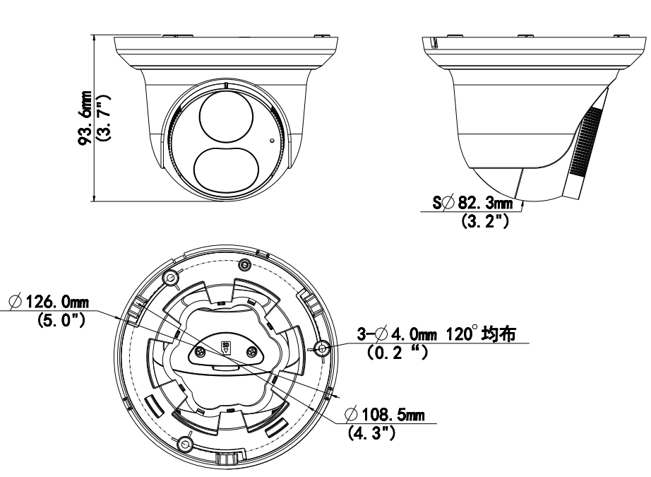
Accessories
TR-JB03-H-IN-V2 | TR-JB03-H-IN | TR-JB07/WM03-F-IN-V2
Junction Box for Metal Turret Camera(Support wiring from behind) | Junction Box for Metal Turret Camera(Support wiring from behind) | Wall Mounting Assembling Bracket with Back Hole for 3 Inch Hemisphere
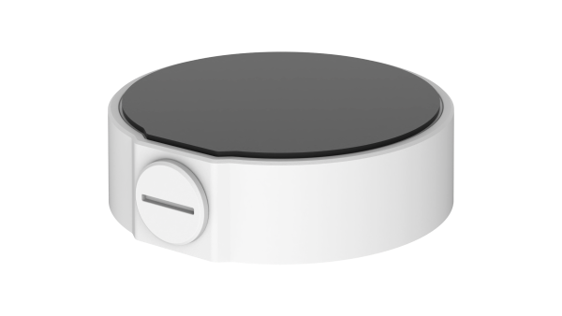 | 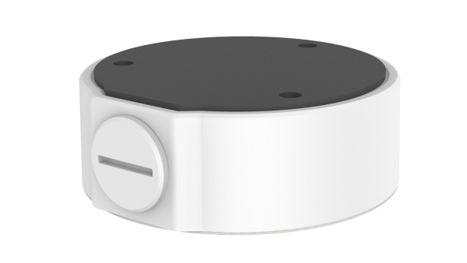 | 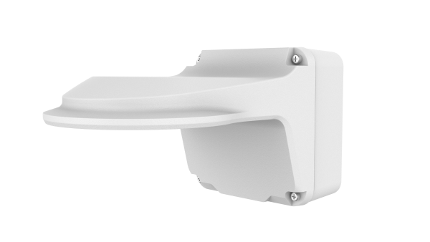
TR-WM03-B-IN-V2 | TR-UP06-C-IN-V2 | TR-A01-IN
Wall Mounting Assembling Bracket for 3 Inch Hemisphere | Pole Mounting Bracket for Bullet Junction Box Only | NPT 3/4'' Waterproof Cable Gland
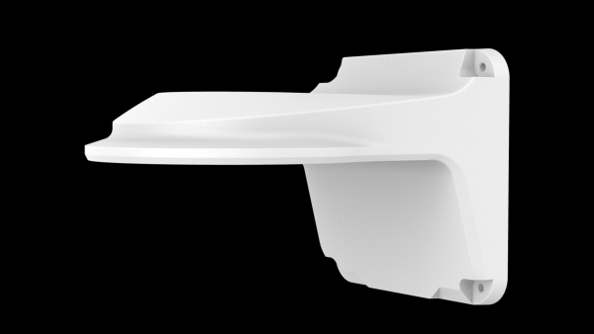 | 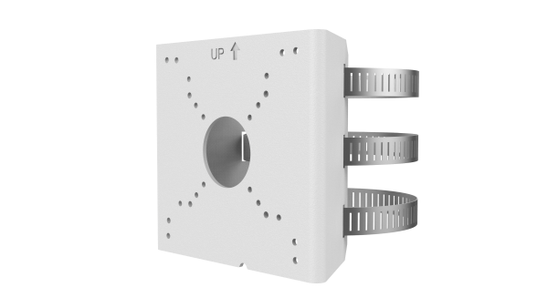 | 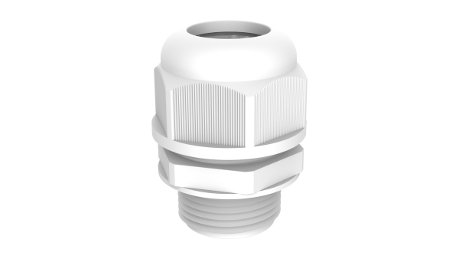
TR-SE24-IN | TR-SE24-A-IN | TR-CM24-IN
Dome Pendent Mounting Pole 200mm | Dome Pendent Mounting Pole 500mm | Dome Pendent Mounting Bracket(Indoor)
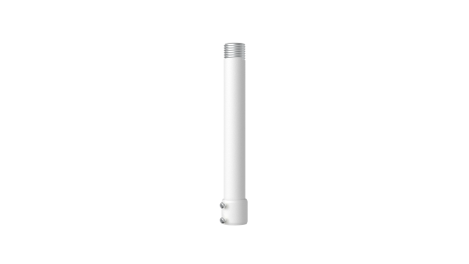 | 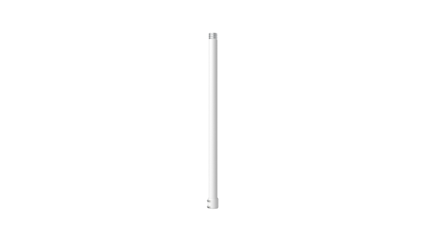 | 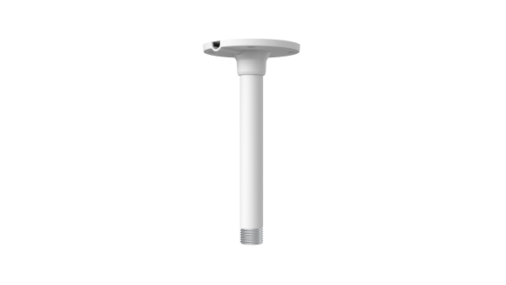
TR-WM03-B-IN | TR-JB07/WM03-F-IN | TR-UC08-C
Wall Mounting Assembling Bracket for 3 Inch Hemisphere | Wall Mounting Assembling Bracket with Back Hole for 3 Inch Hemisphere | Bullet&Dome Corner Mounting Bracket
 |  | 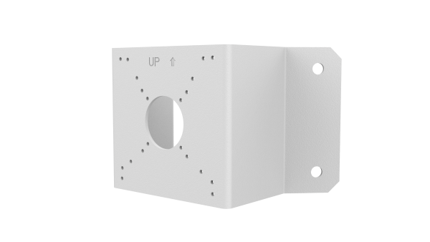
TR-UC08-C-V2
Bullet&Dome Corner Mounting Bracket
