5MP HD Wide Angle Intelligent IR Fixed Eyeball Network Camera
M1T-5F16-180

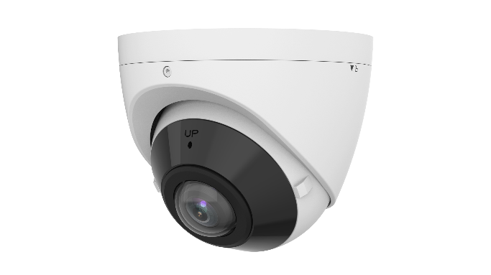

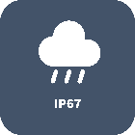

Features
- High quality image with 5 MP, 1/2.7" CMOS sensor
- 5 MP (2880 × 1620)@30/25 fps; 4 MP (2560 × 1440)@30/25 fps; 3 MP (2304 × 1296)@30/25 fps; 1080P (1920 × 1080)@30/25 fps
- Wide angle technology realizes the horizontal viewing angle of 180°
- The dewarp level can be configured in the range of 1 to 9
- Ultra 265, H.265, H.264, MJPEG
- Smart intrusion prevention, including cross line, intrusion, enter area, leave area detection
- Based on target classification, smart intrusion prevention significantly reduces false alarm caused by leaves, birds and lights, accurately focusing on human, motor vehicle and non-motor vehicle
- 120 dB true WDR technology enables clear image in strong light scene
- Built-in mic
- Smart IR, up to 20 m (65.6 ft.) IR distance
- MicroSD, up to 256 GB
- IP67 protection
- IK10 vandal resistant
Specifications
Model | M1T-5F16-180
Camera
Max Resolution | 5 MP
Sensor | 1/2.7" CMOS
Min. Illumination | Color: 0.01 Lux (F2.0, AGC ON), 0 Lux with IR on
Day/Night | IR-cut filter with auto switch (ICR)
Shutter | Auto/Manual, 1 ~ 1/100000s
Adjustment Angle | Pan: 0° to 360°, Tilt: 0° to 75°, Rotate: 0° to 360°
S/N | >52 dB
WDR | 120 dB
Lens
Focal Length | 1.68 mm
Field of View (H) | 180°
Iris Type | Fixed
Iris | F2.0
Field of View (V) | 100°
Field of View (D) | 180°
Lens Type | Fixed
DORI
DORI Distance (Lens) | 1.68 mm
DORI Distance (Detect) | 37.8 m (124.0 ft)
DORI Distance (Observe) | 15.1 m (49.6 ft)
DORI Distance (Recognize) | 7.6 m (24.9 ft)
DORI Distance (Identify) | 3.8 m (12.5 ft)
Illuminator
Supplemental Light | IR
Illumination Distance (IR) | 20 m (65.6 ft)
IR On/Off Control | Auto/Manual
Wavelength | 850 nm
Video
Video Compression | Ultra 265, H.265, H.264, MJPEG
Frame Rate | Main Stream: 5 MP (2880 × 1620), max. 30 fps; 4 MP (2560 × 1440), max. 30 fps; 3 MP (2304 × 1296), max. 30 fps; 1080P (1920 × 1080), max. 30 fps; 1280 × 720 max. 30 fps  Sub Stream: 1080P (1920 × 1080), max. 30 fps; 720P (1280 × 720), max. 30 fps; D1 (720 × 576), max. 30 fps; 640 × 360, max. 30 fps; 2CIF (704 × 288), max. 30 fps; CIF (352 × 288), max. 30 fps;  Third Stream: D1 (720 × 576), max. 30 fps; 640 × 360, max. 30 fps; 2CIF (704 × 288), max. 30 fps; CIF (352 × 288), max. 30 fps
H.264 Code Profile | Baseline profile, Main profile, High profile
Video Bit Rate | 128 Kbps to 16 Mbps
U-code | Support
OSD | Up to 8 OSDs
Privacy Mask | Up to 4 areas
ROI | Support
Video Stream | Triple streams
Image
White Balance | Auto, Outdoor, Fine tune, Sodium lamp, Locked, Auto2
Smart IR | Support
Digital Noise Reduction | 2D/3D DNR
Flip | Normal, Flip vertical, Flip horizontal, 180°
Dewarping | Support
HLC | Support
BLC | Support
Defog | Digital defog
Intelligent
Smart Intrusion Prevention | Cross line detection, intrusion detection, enter area detection, leave area detection (support false alarm filtering and the classification of human, non-motor vehicle and vehicle)
Events
Basic Detection | Motion detection, Ultra motion detection, Tampering alarm, Audio detection
General Function | Watermark, IP address filtering, Access policy, ARP protection, RTSP authentication, User authentication, HTTP authentication
Audio
Audio Compression | G.711U, G.711A, AAC-LC
Audio Bitrate | G.711U/G.711A: 64 kbps, AAC-LC: 128 kbps
Two-way Audio | N/A
Suppression | Support
Sampling Rate | G.711U/G.711A: 8 kHz, AAC-LC: 8 kHz, 16 kHz, 48 kHz
Storage
Edge Storage | MicroSD, up to 512 GB
Network Storage | ANR, NAS (NFS)
Network
Protocols | IPv4, IPv6, IGMP, ARP, TCP, UDP, DHCP, PPPoE, RTP, RTSP, RTCP, RTMP, DNS, DDNS, NTP, FTP, HTTP, HTTPS, SMTP, 802.1x, SNMP, QoS
Compatible Integration | ONVIF (Profile S, Profile G, Profile T, Profile M), API, SDK
User/Host | Up to 32 users. 3 user levels: administrator, common user and operator
Security | Password Protection, Strong Password, HTTPS Encryption, Export Operation Logs, Basic and Digest Authentication for RTSP, Digest Authentication for HTTP, TLS 1.2, WSSE and Digest Authentication for ONVIF
Client | EZStation, APP
Web Browser | Plug-in required live view: IE 10+, Chrome 45+, Firefox 52+, Edge 79+, Plug-in free live view: Chrome 57+, Firefox 58+, Edge 16+
Interface
Audio I/O | N/A
Alarm I/O | N/A
Serial Port | N/A
Built-in Mic | Support
Built-in Speaker | N/A
WIFI | N/A
Network | 1 × RJ45 10 M/100 M Base-TX Ethernet
Video Output | N/A
Certification
EMC | CE-EMC (EN 55032, EN 61000-3-3, EN IEC 61000-3-2, EN 55035)  FCC (FCC 47 CFR part15 B)
Safety | CE LVD (EN 62368-1)  CB (IEC 62368-1)  UL/CUL (UL 62368-1, CAN/CSA C22.2 No. 62368-1)
Environment | CE-RoHS (2011/65/EU;(EU)2015/863); WEEE (2012/19/EU)
Protection | IP67 (IEC 60529)  IK10 (IEC 62262)
General
Power | DC 12 V±25%, PoE (IEEE 802.3af)
Power Consumption | Max. 5.5 W
Power Interface | Ø5.5 mm coaxial power plug
Dimensions | Ø111 mm × 93 mm (Ø4.4" × 3.7") (Ø × H)
Weight | 0.48 kg (1.06 lb)
Material | Metal
Working Environment | -30 ℃ to 60 ℃ (-22 ℉ to 140 ℉), Humidity: ≤ 95% RH (non-condensing)
Storage Environment | -30 ℃ to 60 ℃ (-22 ℉ to 140 ℉), Humidity: ≤ 95% RH (non-condensing)
Surge Protection | 4 KV
Reset Button | Support
Web Client Language | 20 Languages: Traditional Chinese, English, Simplified Chinese, Polish, German, Russian, French, Korean, Dutch, Czech, Portuguese (Europe), Portuguese (Brazil), Japanese, Thai, Turkish, Spanish (Latin America), Spanish (Europe), Hungarian, Italian, Vietnamese
Dimensions
