4MP Wise-ISP Fixed Warm Light Turret Network Camera
O1T-4F28

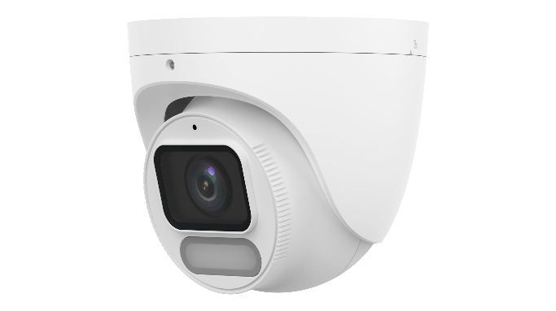

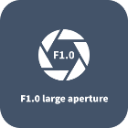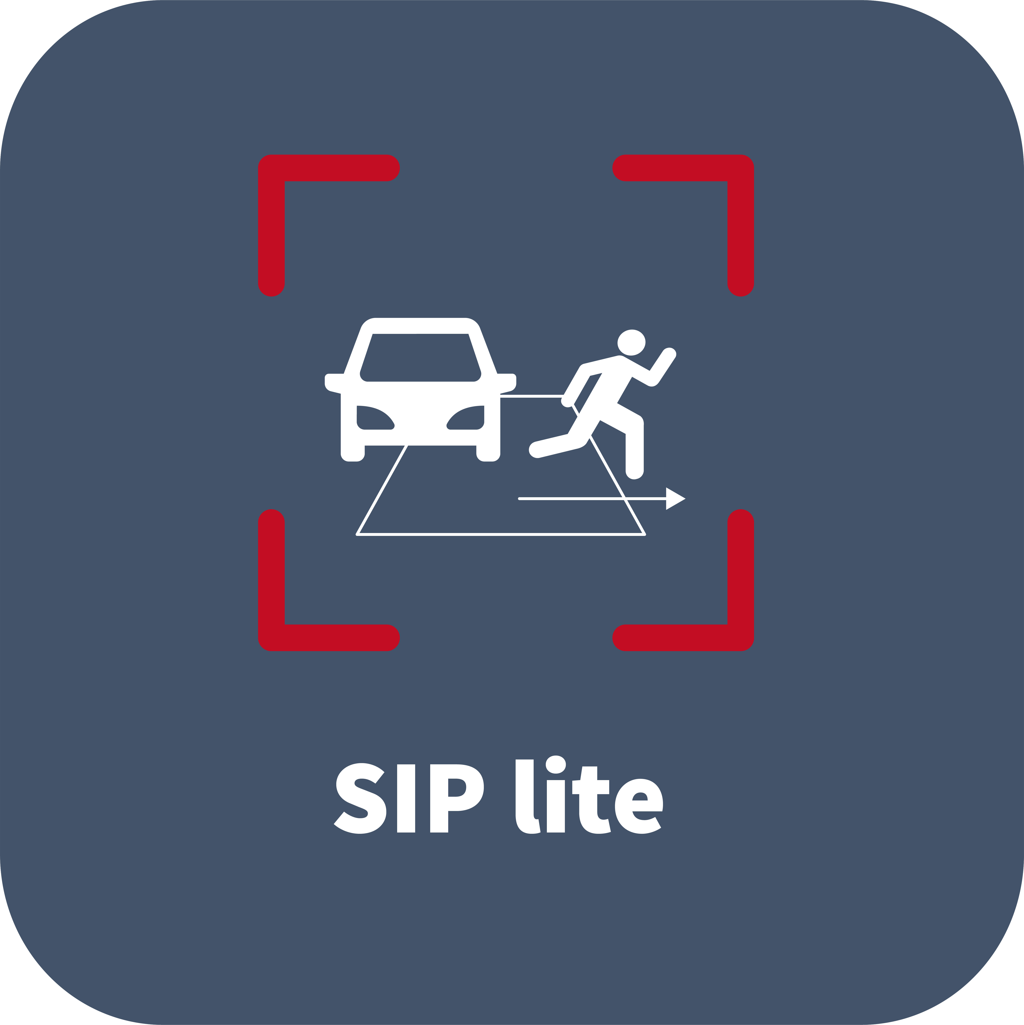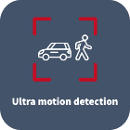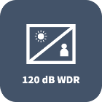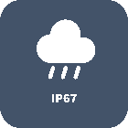

Features
- High quality image with 4 MP, 1/1.8" CMOS sensor and F1.0 large aperture lens
- 4 MP (2688 × 1520)@25/20 fps; 4 MP (2560 × 1440)@25/20 fps; 3 MP (2304 × 1296)@30/25 fps; 1080P (1920 × 1080)@30/25 fps
- Ultra 265, H.265, H.264, MJPEG(Sub Stream Only)
- Supports Wise-ISP technology, deeply optimizing color, detail, and smear effects in extremely low-light scenes
- Support cross line, intrusion detection (based on human body detection and vehicle detection)
- Support ultra motion detection (human/ vehicle detection)
- 120 dB true WDR technology enables clear image in strong light scene
- Supports 9:16 corridor mode
- Built-in mic
- White light, up to 30 m (98.4 ft) warm light distance
- MicroSD, up to 512 GB
- IP67 protection
- Supports PoE power supply
Specifications
Model | O1T-4F28
Camera
Max Resolution | 4 MP
Sensor | 1/1.8" CMOS
Min. Illumination | Color: 0.0003 Lux (F1.0, AGC ON)
Shutter | Auto/Manual, 1 to 1/100000 s
Adjustment Angle | Pan: 0° to 360°, Tilt: 0° to 75°, Rotate: 0° to 360°
S/N | > 52 dB
WDR | 120 dB
Lens
Focal Length | 2.8 mm
Iris | F1.0
Field of View (H) | 117.7 °
Field of View (V) | 68.7 °
Field of View (D) | 140.7 °
Lens Type | Fixed
Iris Type | Fixed
DORI
DORI Distance (Lens) | 2.8 mm
DORI Distance (Detect) | 61.4 m (201.5 ft)
DORI Distance (Observe) | 24.6 m (80.6 ft)
DORI Distance (Recognize) | 12.3 m (40.3 ft)
DORI Distance (Identify) | 6.1 m (20.2 ft)
Illuminator
Illumination Distance (Warm Light) | 30 m (98.4 ft)
Light On/Off Control | Auto/Manual
Supplemental Light | Warm light
Video
Video Compression | Ultra 265, H.265, H.264, MJPEG (Sub Stream Only)
H.264 Code Profile | Baseline profile, Main profile, High profile
Frame Rate | Main Stream: 4 MP (2688 × 1520), max. 25 fps; 4 MP (2560 × 1440), max. 25 fps; 3 MP (2304 × 1296), max. 30 fps; 1080P (1920 × 1080), max. 30 fps;720P (1280 × 720), max. 30 fps；  Sub Stream: 720P (1280 × 720), max. 30 fps; D1 (720 × 576), max. 30 fps; 640 × 360, max. 30 fps; 2CIF (704 × 288), max. 30 fps; CIF (352 × 288), max. 30 fps
Video Bit Rate | 128 Kbps to 6144 Kbps
OSD | Up to 4 OSDs
Privacy Mask | Up to 4 areas
ROI | Up to 8 areas
U-code | Support
Video Stream | Dual streams
Snapshot | Support
Snapshot Resolution | 2688*1520; 2560 × 1440; 2304 × 1296; 1920 × 1080; 1280 × 720; 720 × 576; 640 × 360; 704 × 288; 352 × 288
Image
Smart Illumination | Support
White Balance | Auto, Outdoor, Fine tune, Sodium lamp, Locked, Auto2, Area white balance
Digital Noise Reduction | 2D/3D DNR
Flip | Normal, Flip vertical, Flip horizontal, 180°, 90° Clockwise, 90° Anti-clockwise
HLC | Support
Dewarping | N/A
BLC | Support
Defog | Digital defog
Intelligent
Smart Intrusion Prevention (Lite) | Intrusion, crossline detection (both detection are based on human body and vehicle detection)
Events
Basic Detection | Motion detection, Ultra motion detection (based on human body and vehicle detection), Tampering alarm, Audio detection
General Function | Watermark, IP address filtering, Access policy, ARP protection, RTSP authentication, User authentication, HTTP authentication
Audio
Audio Compression | G.711U, G.711A, AAC-LC
Audio Bitrate | G.711U/G.711A: 64 kbps, AAC-LC: 128 kbps
Two-way Audio | N/A
Suppression | Support
Sampling Rate | G.711U/G.711A: 8 kHz, AAC-LC: 8 kHz, 16 kHz, 48 kHz
Storage
Edge Storage | MicroSD, up to 512 GB
Network Storage | ANR, NAS (NFS)
Network
Protocols | IPv4, IPv6, IGMP, ICMP, ARP, TCP, UDP, DHCP, PPPoE, RTP, RTSP, RTCP, DNS, DDNS, NTP, FTP, UPnP, HTTP, HTTPS, SMTP, 802.1x, SNMP, QoS, RTMP, SSL/TLS
Compatible Integration | ONVIF (Profile S, Profile G, Profile T), API, SDK
Client | EZStation, APP
Web Browser | Plug-in required live view: IE 10+, Chrome 45+, Firefox 52+, Edge 79+, Plug-in free live view: Chrome 57+, Firefox 58+, Edge 16+
Security | Password protection, Strong Password, HTTPS encryption, Export operation logs, Basic and Digest Authentication for RTSP, Digest Authentication for HTTP, TLS 1.2, WSSE and Digest Authentication for ONVIF
User/Host | Up to 32 users. 2 user levels: administrator and common user
Interface
Audio I/O | N/A
Alarm I/O | N/A
Serial Port | N/A
Built-in Mic | Support
Built-in Speaker | N/A
WIFI | N/A
Network | 1 × RJ45 10 M/100 M Base-TX Ethernet
Video Output | N/A
Certification
EMC | CE-EMC (EN 55032, EN 61000-3-3, EN IEC 61000-3-2, EN 50130-4)  FCC (FCC 47 CFR part15 B)
Safety | CE-LVD (EN 62368-1)  UL/CUL (UL 62368-1, CAN/CSA C22.2 No. 62368-1)
Environment | CE-RoHS (2011/65/EU ; (EU) 2015/863) ; WEEE (2012/19/EU)
Protection | IP67 (IEC 60529)
General
Power | DC 12 V±25%, PoE (IEEE 802.3af)
Power Consumption | Max. 3 W
Power Interface | Ø5.5 mm coaxial power plug
Dimensions | Ø118 mm × 108 mm (Ø4.6" × 4.3") (Ø × H)
Material | Metal
Working Environment | -30 ℃ to 60 ℃ (-22 ℉ to 140 ℉), Humidity: ≤ 95% RH (non-condensing)
Storage Environment | -30 ℃ to 60 ℃ (-22 ℉ to 140 ℉), Humidity: ≤ 95% RH (non-condensing)
Surge Protection | 4 KV
Reset Button | Support
Web Client Language | 14 Languages: English, Simplified Chinese, Polish, German, Russian, French, Korean, Dutch, Czech, Portuguese, Spanish, Spanish (Europe), Italian, Turkish
Dimensions
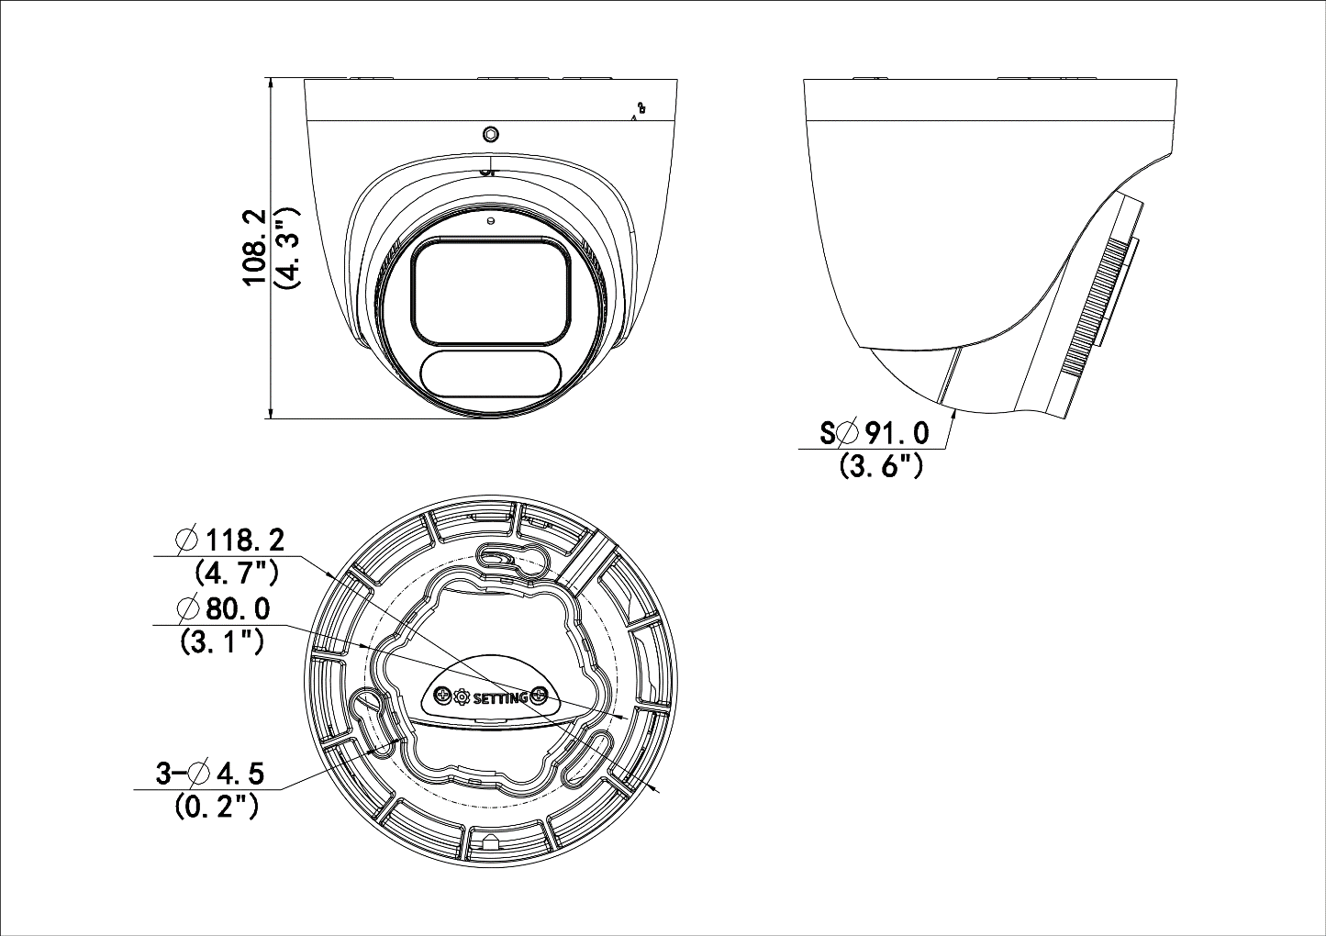
Accessories
TR-JB03-I-IN | TR-CM24-IN | TR-SE24-A-IN
Junction Box for Turret Camera(Support wiring from behind) | Dome Pendent Mounting Bracket(Indoor) | Dome Pendent Mounting Pole 500mm
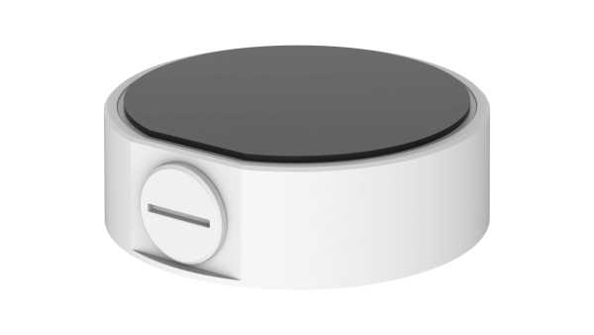 | 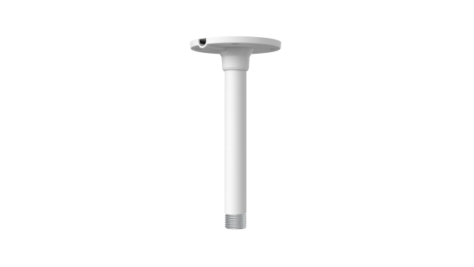 | 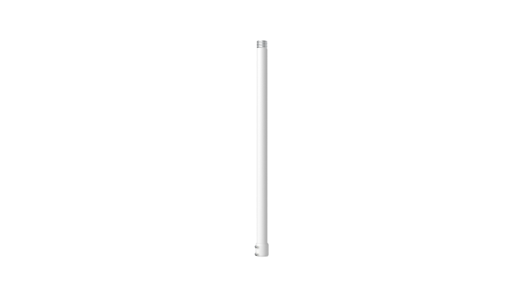
TR-SE24-IN | TR-A01-IN | TR-JB07/WM03-G-IN-V2
Dome Pendent Mounting Pole 200mm | NPT 3/4'' Waterproof Cable Gland | Wall Mounting Assembling Bracket For 32 Fix-dome&Mini Fix-dome&Plastic Turret Camera
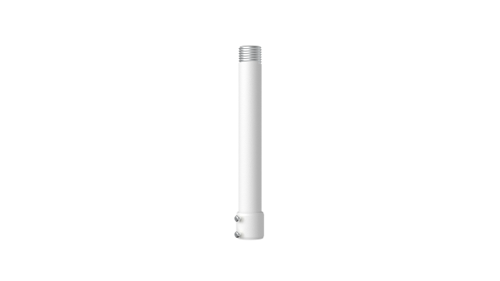 | 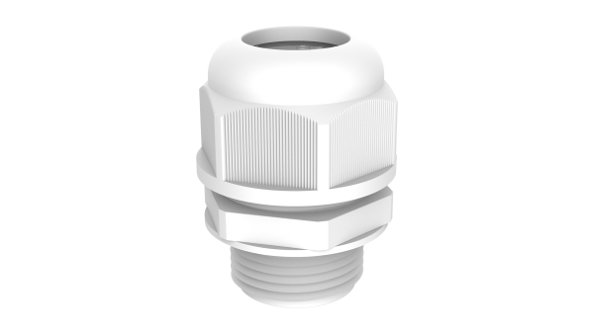 | 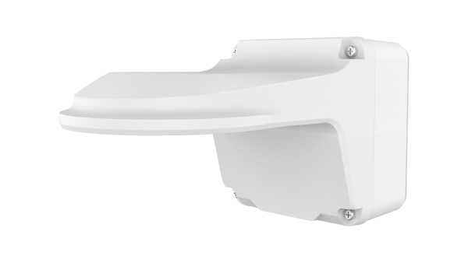
TR-WM03-D-IN-V2 | TR-UC08-C-V2 | TR-UP06-C-IN-V2
Wall Mounting Bracket for 32 Fix-dome&Mini Fix-dome&Plastic Turret Camera | Bullet&Dome Corner Mounting Bracket | Pole Mounting Bracket for Bullet Junction Box Only
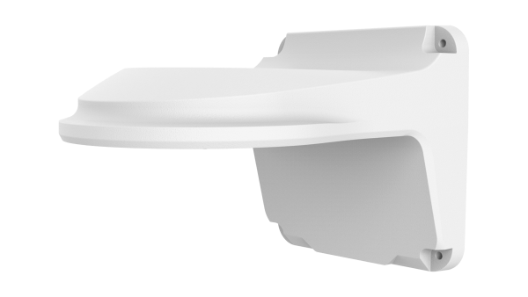 | 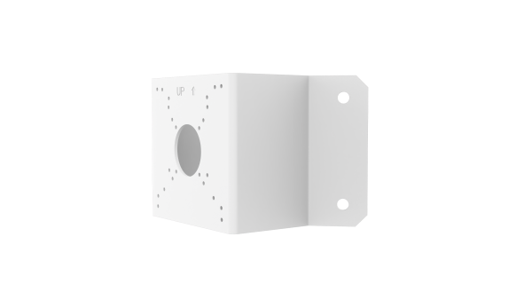 | 