8MP ColorHunter with Wise-ISP Fixed Turret Network Camera
O2T-8F28

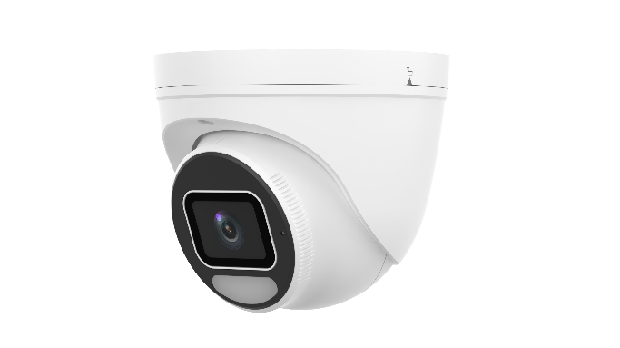

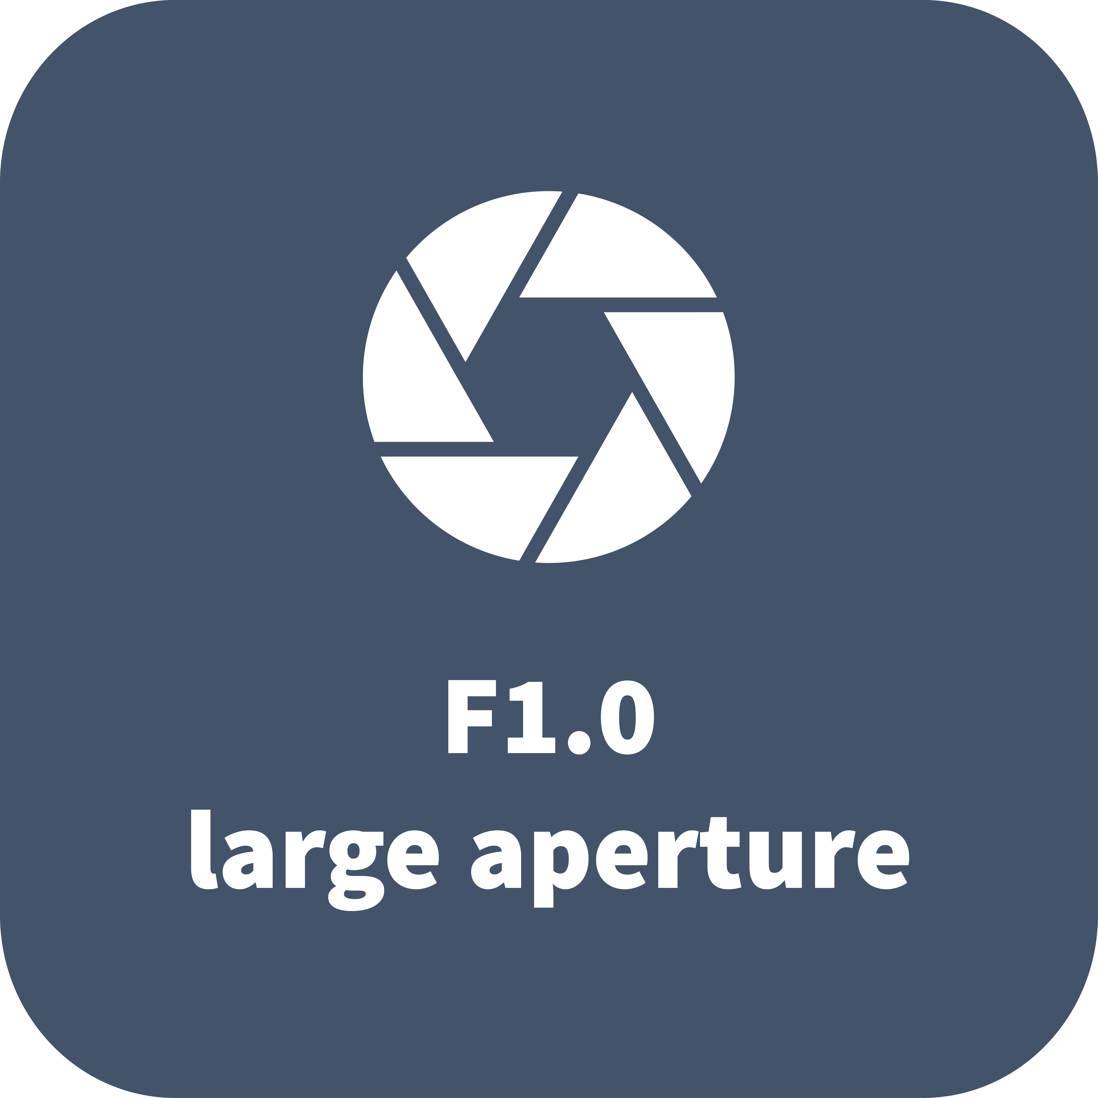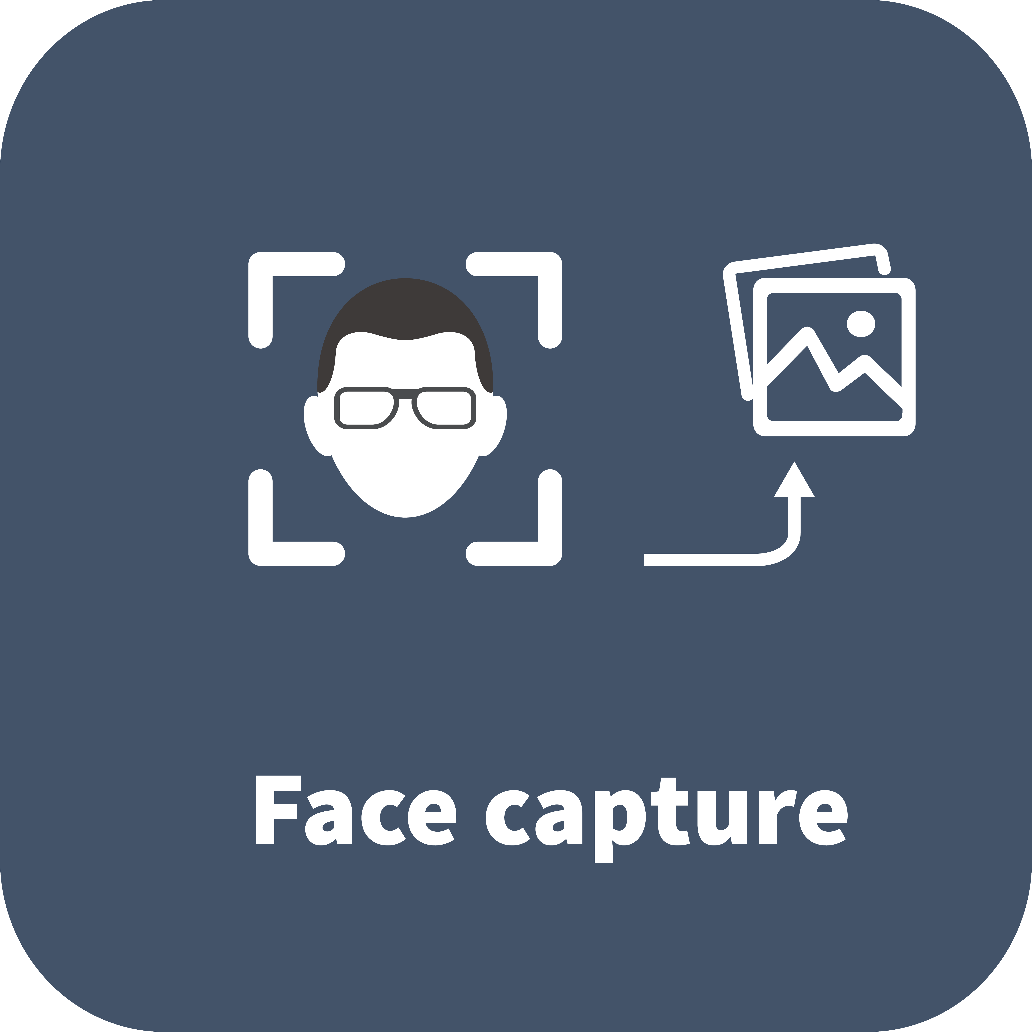

Features
- High quality image with 8 MP, 1/1.2" CMOS sensor
- 8 MP (3840 × 2160)@30/25 fps; 5.3 MP (3072 × 1728)@30/25 fps; 3.6 MP (2560 × 1440)@30/25 fps; 1080P (1920 × 1080)@30/25 fps; 720P (1280 × 720), max. 30/25 fps
- Ultra 265, H.265, H.264, MJPEG
- ColorHunter with Wise-ISP technology ensures 24-hour full-color images
- Intelligent perimeter protection, including cross line, intrusion, enter area, leave area detection
- Based on target classification, smart intrusion prevention significantly reduces false alarm caused by leaves, birds and lights, accurately focusing on human, motor vehicle and non-motor vehicle
- Intelligent people flow counting and crowd density monitoring
- Smart intrusion prevention with color retrieval
- ASM (auto scene match)
- 130 dB true WDR technology enables clear image in strong light scene
- Supports 9:16 corridor mode
- Alarm I/O: 1/1, audio I/O: 1/1, built-in mic
- White light, up to 30 m (98.4 ft) warm light distance
- MicroSD, up to 512 GB
- Supports NEMA 4X, IK10 vandal resistant and IP67 protection
Specifications
Model | O2T-8F28
Camera
Max Resolution | 8 MP
Sensor | 1/1.2" CMOS
Min. Illumination | Color: 0.0003 Lux (F1.0, AGC ON)
Shutter | Auto/Manual, 1 to 1/100000 s
Adjustment Angle | Pan: 0° to 360°, Tilt: 0° to 75°, Rotate: 0° to 360°
S/N | >56 dB
WDR | 130 dB
Lens
Focal Length | 2.8 mm
Iris Type | Fixed
Iris | F1.0
Field of View (H) | 105.0°
Field of View (V) | 56.1°
Field of View (D) | 121.0°
Lens Type | Fixed
DORI
DORI Distance (Lens) | 2.8 mm
DORI Distance (Detect) | 43.4 m (142.4 ft)
DORI Distance (Observe) | 17.4 m (57.1 ft)
DORI Distance (Recognize) | 8.7 m (28.5 ft)
DORI Distance (Identify) | 4.3 m (14.1 ft)
Illuminator
Supplemental Light | Warm light
Illumination Distance (Warm Light) | 30 m (98.4 ft)
Light On/Off Control | Auto/Manual
Video
Video Compression | Ultra 265, H.265, H.264, MJPEG
H.264 Code Profile | Baseline profile, Main profile, High profile
Frame Rate-Main Stream | 8 MP (3840 × 2160), max. 30 fps; 5.3 MP (3072 × 1728), max. 30 fps; 3.6 MP (2560 × 1440), max. 30 fps; 1080P (1920 × 1080), max. 30 fps; 720P (1280 × 720), max. 30 fps
Frame Rate-Sub Stream | 1080P (1920 × 1080), max. 30 fps; 720P (1280 × 720), max. 30 fps; D1 (720 × 576), max. 30 fps; 640 × 360, max. 30 fps; 2CIF (704 × 288), max. 30 fps; CIF (352 × 288), max. 30 fps
Frame Rate-Third Stream | D1 (720 × 576), max. 30 fps; 640 × 360, max. 30 fps; 2CIF (704 × 288), max. 30 fps; CIF (352 × 288), max. 30 fps
Video Bit Rate | 128 Kbps to 16 Mbps
U-code | Support
OSD | Up to 8 OSDs
Privacy Mask | Up to 4 areas
ROI | Support
Video Stream | Triple streams
Image
White Balance | Auto, Outdoor, Fine tune, Sodium lamp, Locked, Auto2
Digital Noise Reduction | 2D/3D DNR
Flip | Normal, Flip vertical, Flip horizontal, 180°, 90° Clockwise, 90° Anti-clockwise
Dewarping | N/A
HLC | Support
BLC | Support
Defog | Digital defog
Intelligent
Statistical Analysis | N/A
People Counting | Support people flow counting and crowd density detection
Attribute Collection | SIP with color retrieval
Events
Basic Detection | Motion detection, Ultra motion detection, Tampering alarm, Audio detection, Object removed, Object Left Behind
General Function | Watermark, IP address filtering, Access policy, ARP protection, RTSP authentication, User authentication, HTTP authentication, Alarm input, Alarm output
Audio
Audio Compression | G.711U, G.711A, AAC-LC
Audio Bitrate | G.711U/G.711A: 64 kbps, AAC-LC: 128 kbps
Two-way Audio | Support
Suppression | Support
Sampling Rate | G.711U/G.711A: 8 kHz, AAC-LC: 8 kHz, 16 kHz, 48 kHz
Storage
Edge Storage | MicroSD, up to 512 GB
Network Storage | ANR, NAS (NFS)
Network
Security | Password Protection, Strong Password, HTTPS Encryption, Export Operation Logs, Basic and Digest Authentication for RTSP, Digest Authentication for HTTP, TLS 1.2, WSSE and Digest Authentication for ONVIF
Protocols | IPv4, IPv6, IGMP, ICMP, ARP, TCP, UDP, DHCP, PPPoE, RTP, RTSP, RTCP, RTMP, DNS, DDNS, NTP, FTP, UPnP, HTTP, HTTPS, SMTP, 802.1x, SNMP, QoS, SSL/TLS, SSH
Compatible Integration | ONVIF (Profile S, Profile G, Profile T, Profile M), API, SDK
User/Host | Up to 32 users. 3 user levels: administrator, common user and operator
Client | EZStation, APP
Web Browser | Plug-in required live view: IE 10+, Chrome 45+, Firefox 52+, Edge 79+, Plug-in free live view: Chrome 57+, Firefox 58+, Edge 16+
Interface
Audio I/O | 1 Input: impedance 35 kΩ, amplitude 2 V [p-p], 1 Output: impedance 600 Ω, amplitude 2 V [p-p]
Alarm I/O | 1/1
Serial Port | N/A
Built-in Mic | Support
Built-in Speaker | N/A
WIFI | N/A
Network | 1 × RJ45 10 M/100 M Base-TX Ethernet
Video Output | N/A
Certification
EMC | CE-EMC (EN 55032, EN 61000-3-3, EN IEC 61000-3-2, EN 50130)  FCC (FCC 47 CFR part15 B)
Safety | CE-LVD (EN 62368-1)  UL/CUL (UL 62368-1, CAN/CSA C22.2 No. 62368-1)
Environment | CE-RoHS (2011/65/EU;(EU)2015/863); WEEE (2012/19/EU)
Protection | IP67 (IEC 60529)  IK10 (IEC 62262)  NEMA 4X
General
Power | DC 12 V±25%, PoE (IEEE 802.3af)
Power Consumption | Max. 6.0 W
Power Interface | Ø5.5 mm coaxial power plug
Dimensions | Ø129 mm × 110 mm (Ø5.1" × 4.3") (Ø × H)
Weight | 0.69 kg (1.52 lb)
Material | Metal
Working Environment | -40 ℃ to 60 ℃ (-40 ℉ to 140 ℉), Humidity: ≤ 95% RH (non-condensing)
Storage Environment | -40 ℃ to 60 ℃ (-40 ℉ to 140 ℉), Humidity: ≤ 95% RH (non-condensing)
Surge Protection | 4 KV
Reset Button | Support
Web Client Language | 20 Languages: Traditional Chinese, English, Simplified Chinese, Polish, German, Russian, French, Korean, Dutch, Czech, Portuguese (Europe), Portuguese (Brazil), Japanese, Thai, Turkish, Spanish (Latin America), Spanish (Europe), Hungarian, Italian, Vietnamese
Built-in DC12V Output | Support
Dimensions
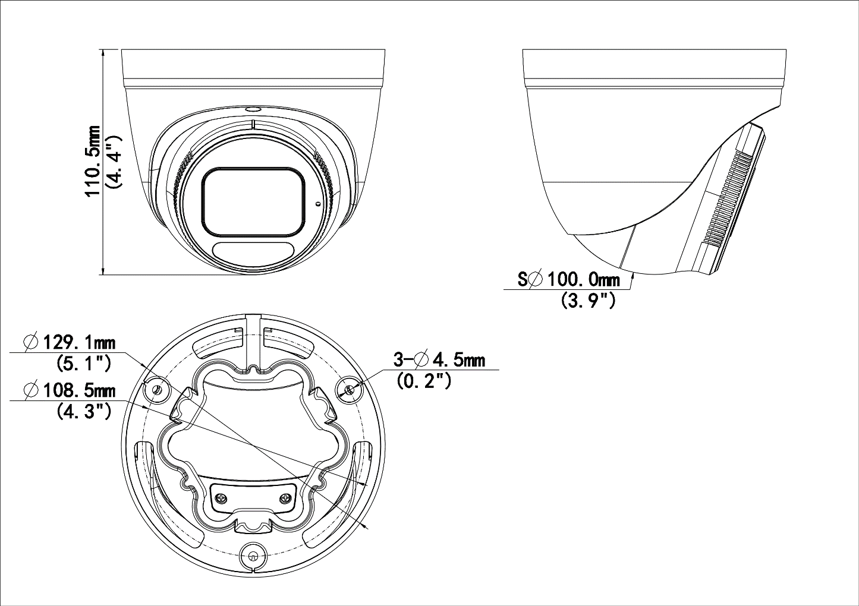
Accessories
TR-JB03-H-IN-V2 | TR-A01-IN | TR-SE24-IN
Turret Junction Box(Support Wiring From Behind) | NPT 3/4'' Waterproof Cable Gland | Dome Pendent Mounting Pole 200mm
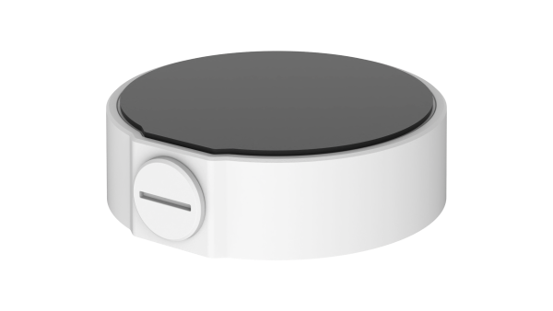 | 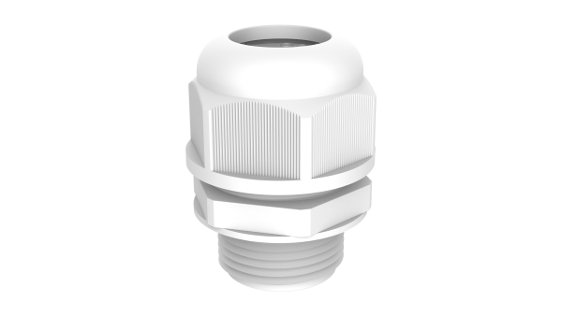 | 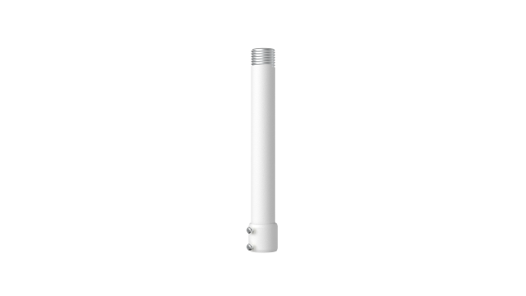
TR-SE24-A-IN | TR-CM24-IN | TR-UC08-C-V2
Dome Pendent Mounting Pole 500mm | Dome Pendent Mounting Bracket(Indoor) | Bullet&Dome Corner Mounting Bracket
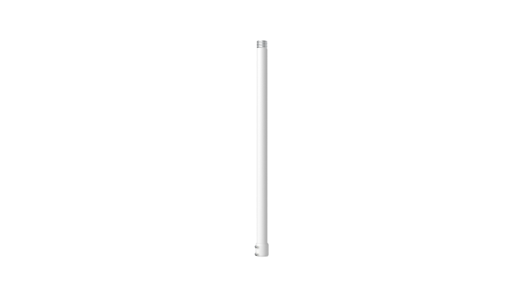 | 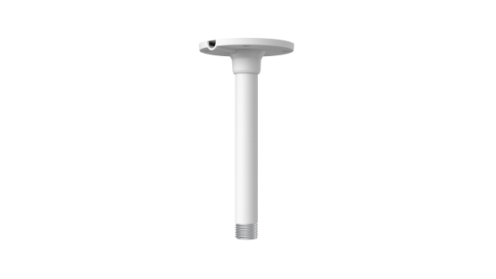 | 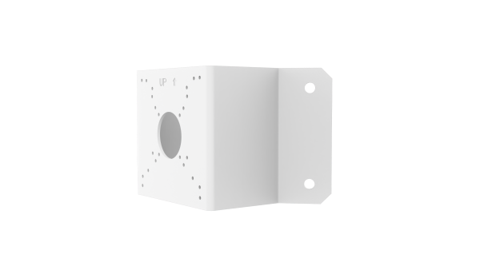
TR-JB07/WM03-F-IN-V2 | TR-WM03-B-IN-V2 | TR-UP06-C-IN-V2
Wall Mounting Assembling Bracket with Back Hole For 3 Inches Dome | 3 Inches Dome Wall Mounting Assembling Bracket | Pole Mounting Bracket For Bullet Junction Box Only
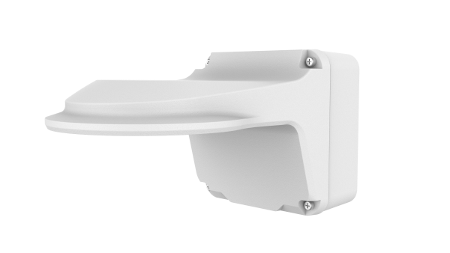 | 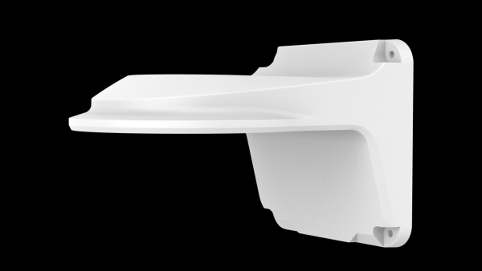 | 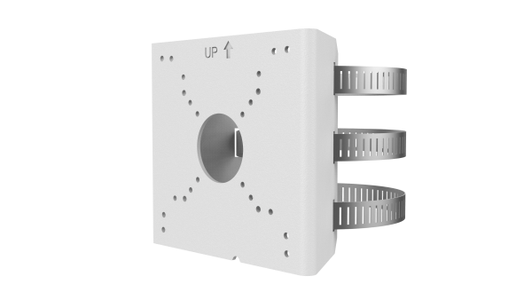
TR-JB03-J-IN
VF Turret Junction Box(Support Wiring From Behind)
